**Recipe Cove**

**System Design Documentation**

*(Laboratory of Advanced Programming 2022/2023)*

Valerio Di Stefano (1898728) & Giuseppe Prisco (1895709)

# Index

**Index 1**

**Abstract 2**

**1 Introduction 2**

**2 System Infrastructure 3**

**3 Deployment 5**

**4 User Stories of the system 6**

**5 Mockups 11**

5.1 Home Page 11

5.2 Search Results Page 12

5.3 Recipe Page 12

5.4 Ingredient Page 13

5.5 User Profile Page 14

5.6 Recipe Calendar Event 15

5.7 Chat-BOT (Menu) 15

5.8 Storyboard 17

**6 Function Points Estimation and COCOMO II 18**

6.1 Function Points 18

6.2 COCOMO II 20

6.3 Adopted Excel Sheets 21

**7 Development Process - Scrum & Sprint Reports 24**

7.1 SCRUM 24

7.1.1 Gantt Chart 25

7.1.2 Burndown chart 27

7.1.3 Release Backlog 27

7.2 Sprint Reports 29

7.2.1 Sprint #1 29

7.2.2 Sprint #2 30

7.2.3 Sprint #3 32

7.2.4 Sprint #4 33

7.2.5 Sprint #5 34

7.2.6 Sprint #6 36

7.2.7 Sprint summary 37

**8 Graphical User Interface 39**

8.1 Home Page 39

8.2 Search Results Page 40

8.3 Recipe Page 41

8.4 Ingredient Page 42

8.5 User Profile page 42

8.6 Recipe Calendar Event 43

8.7 Chat-BOT (Menu) 43

# Abstract

The goal of this document is to present all the work that has been done before and during the development of the system. The first section aims at introducing the general aspects of the system, identifying the general functionalities that the final application should have. Then, a brief overview of the infrastructure adopted is presented and detailed, followed by the instructions needed for the deployment of the system. We then present the user stories and first Mockups of the system in the fourth and fifth section of the document, followed by the Function Points, effort, time and cost estimation presented in section six.

In the second half of the document we present the methodologies employed during the development process starting from section seven, in which we describe the SCRUM roles adopted, the methodologies and ceremonies followed by the team and the artifacts produced during the development cycle. We also present the plan and goals for each sprint we conducted during the system implementation.

In the final section of the document we provide the final Graphical User Interface for the system, in the form of screenshots for each of the application’s pages.

# 1 Introduction

The main idea for our project consists of a web application about recipes, food and cooking. Our goal was to provide an easy-to-use tool to aid in recipe discovering, bookmarking as well as finding exhaustive information about recipes and ingredients.

The central focus of the system is therefore the discovery of a wide range of recipes, through the use of a search bar, or with the use of a Chat-BOT which will suggest recipes to the user, following a specific diet.

Additionally, the user has the ability to keep a personal profile within the system, which will allow him to see his basic information, but also the ability to save recipes in a favorite list and publish reminders in an application-created calendar.

The following ER Schema should allow the reader to recognize the entities that have a major role for our system:

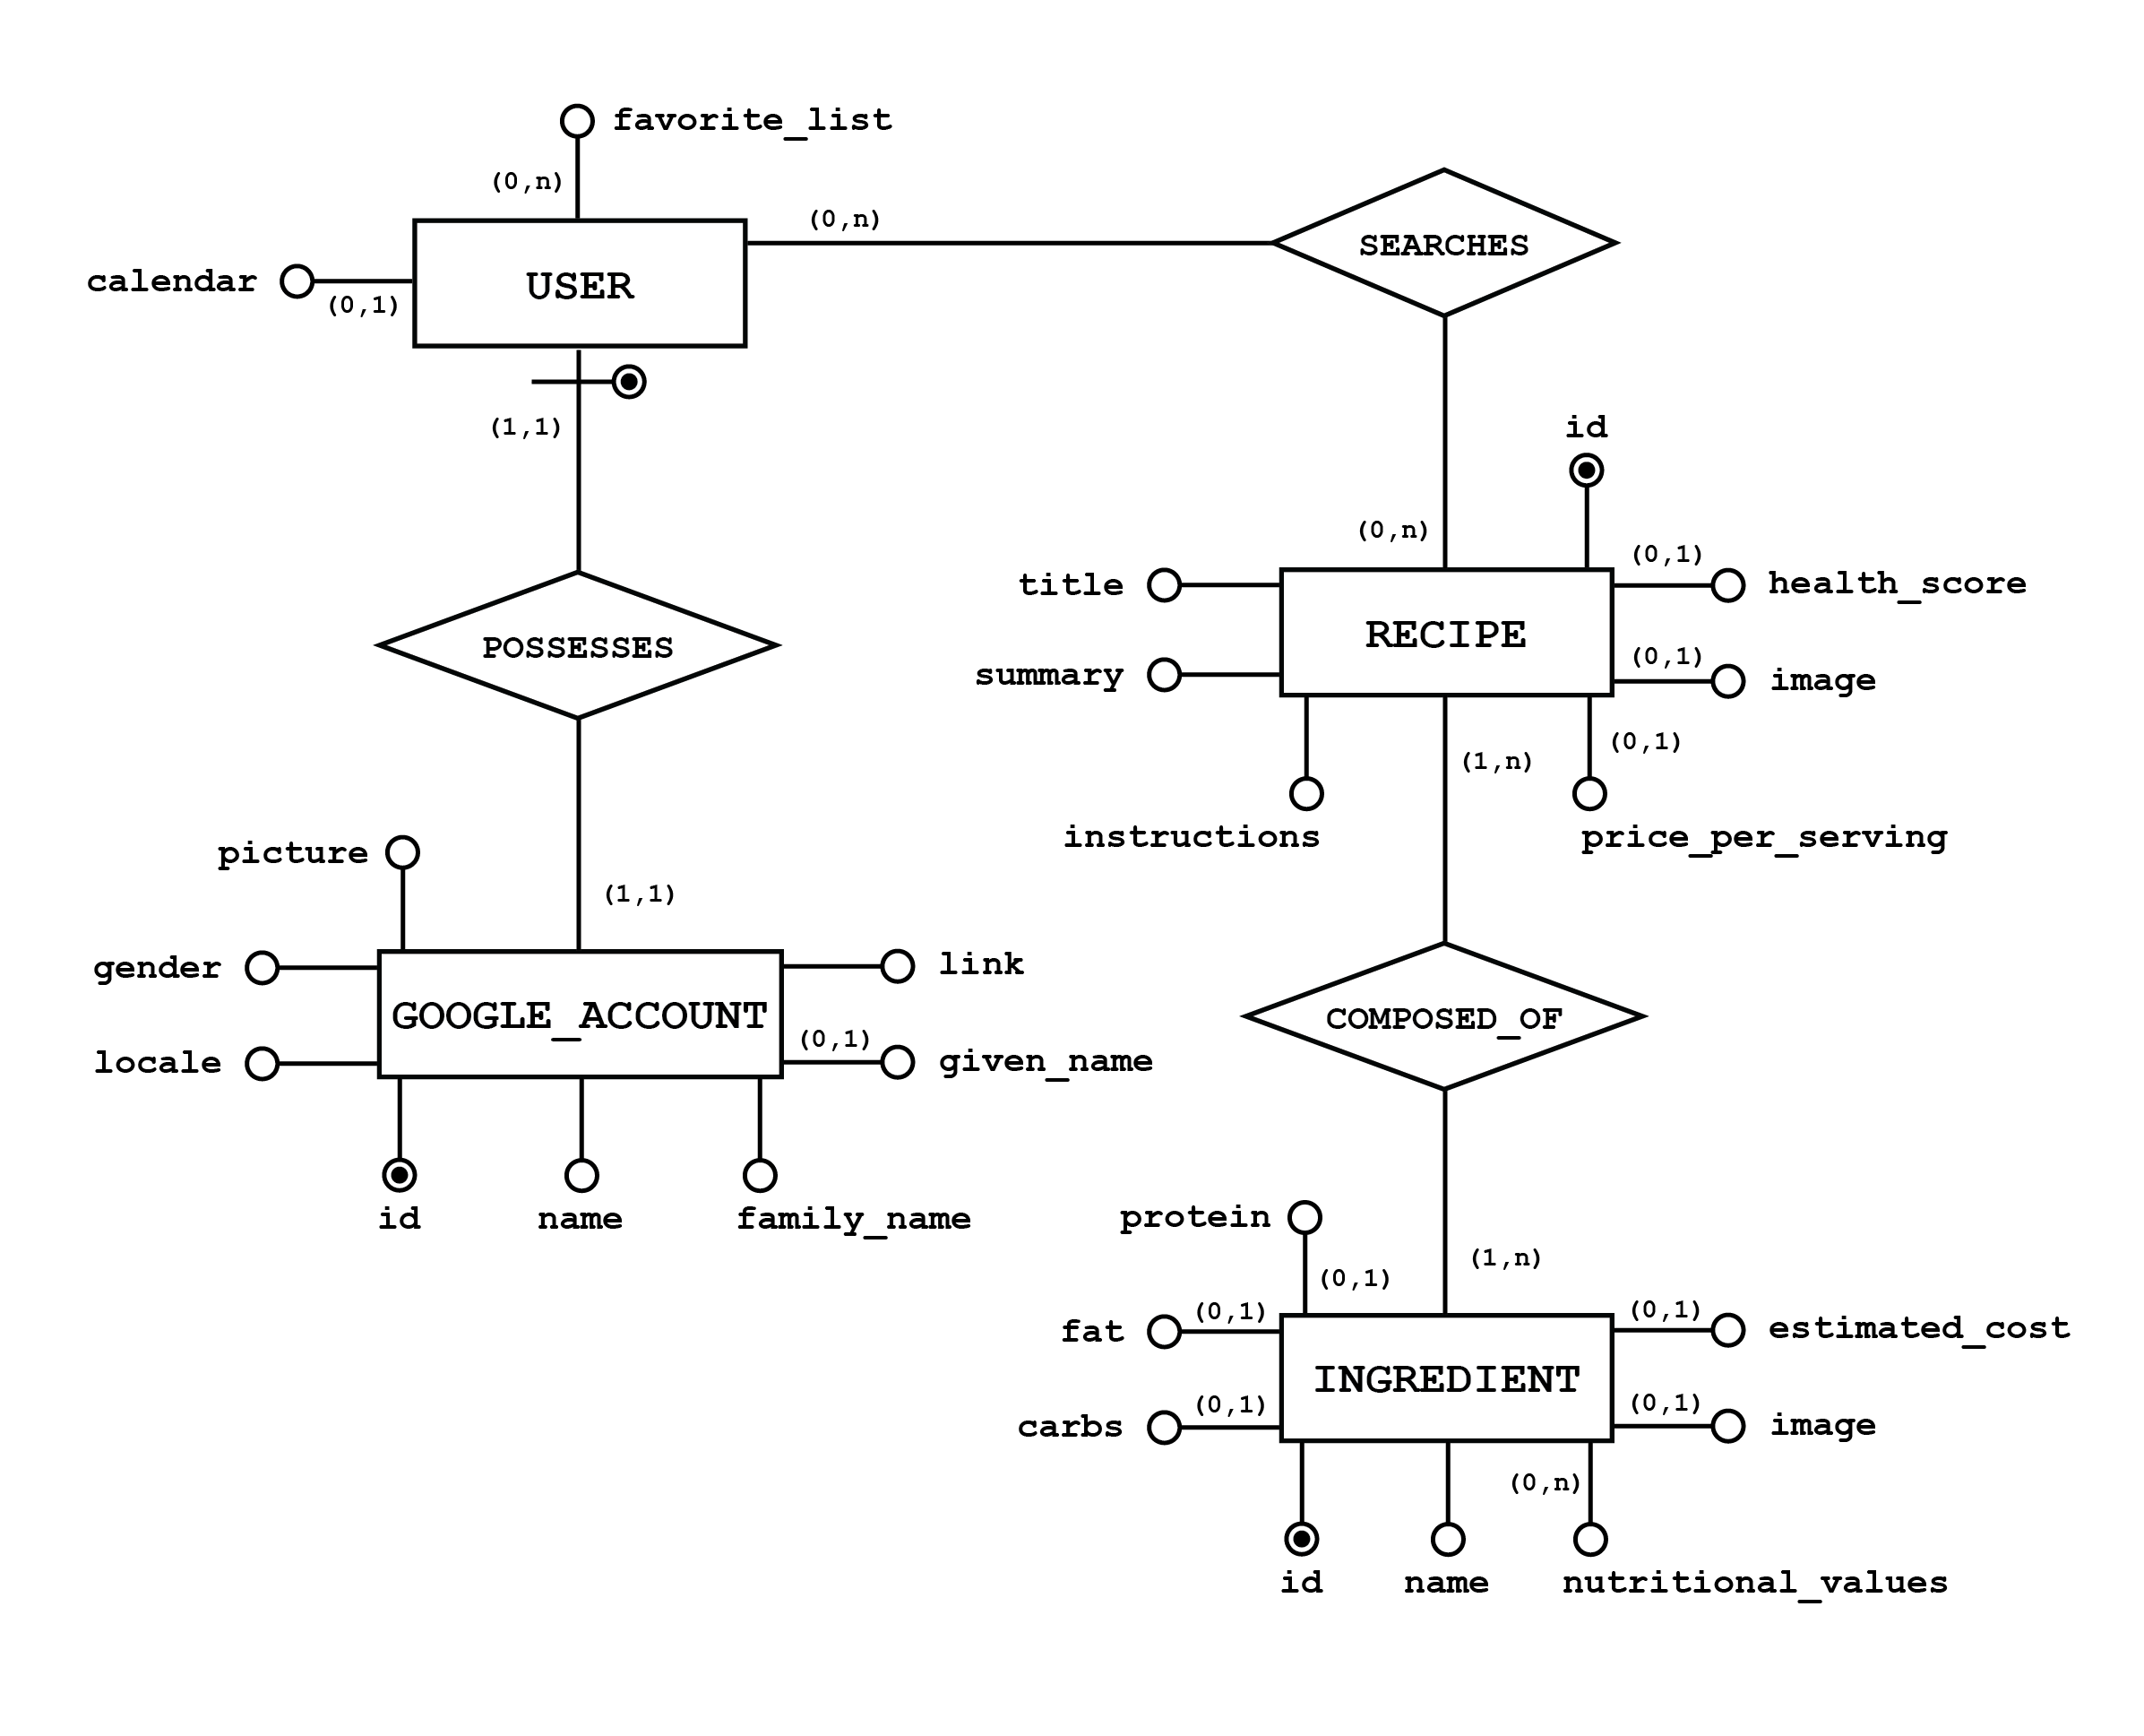

# 2 System Infrastructure

The system is composed of several components, running on different Docker containers. Through the use of the docker compose tool, it is possible to re-deploy the whole environment on different clients, with a single instruction.

We also provided a simple script which allows to run the system with just a click.

The different main components that have been implemented in our system are the following:

* Webapp container: it is the main container of the system, based on Node.js, which contains the majority of the core functionalities of the system. It uses Express.js, a routing and middleware web framework, as the main application framework for executing the following middleware functions:
  + Application-level middleware, to manage routes and their handler functions;
  + Built-in middleware, which are built-in function, to serve static elements (with express.static) or to properly encode the payloads (with express.urlencoded)
  + Third-party middleware, used to include several third-party functionalities, such as the management of the session or the correct parsing of the body of HTTP requests

The main functionalities included in the main container are the registration and login of the user with an existing Google account, the management of his profile, the Chat-BOT microservice implemented using web sockets, and the management of the discovery and visualization of recipes and their information as well as ingredients and related data.

* Calendar container: this container is employed to serve the Google Calendar microservice. It allows the user to create a Google Calendar directly from our system, while also allowing him to correctly delete it from the application. Additionally, there is the possibility for the user to directly create an event (which will function as a reminder) for each recipe the user may intend to prepare on a specific day.
* CouchDB container: it is used as the persistent layer of our system. Its main function is to store the data related to users, including personal information and the recipes added to the favorite list. CouchDB is a document based database, providing a straightforward communication and management of files in the form of JSON documents, which in turn are easily parsable and not too verbose. Additionally, CouchDB provides resiliency of data in the form of replication, always keeping a replica set for the stored data and providing fault tolerance.
* Nodemailer container: this container is devoted to providing a mail service, sending emails to the users that are registered in our application. It communicates with the Webapp container through the RabbitMQ container.
* RabbitMQ container: this container allows communication, in an asynchronous exchange of messages, between the Webapp and the Nodemailer containers. It works as a middleware that provides multiple messaging protocols.

An image that summarizes the whole architecture can be the following:

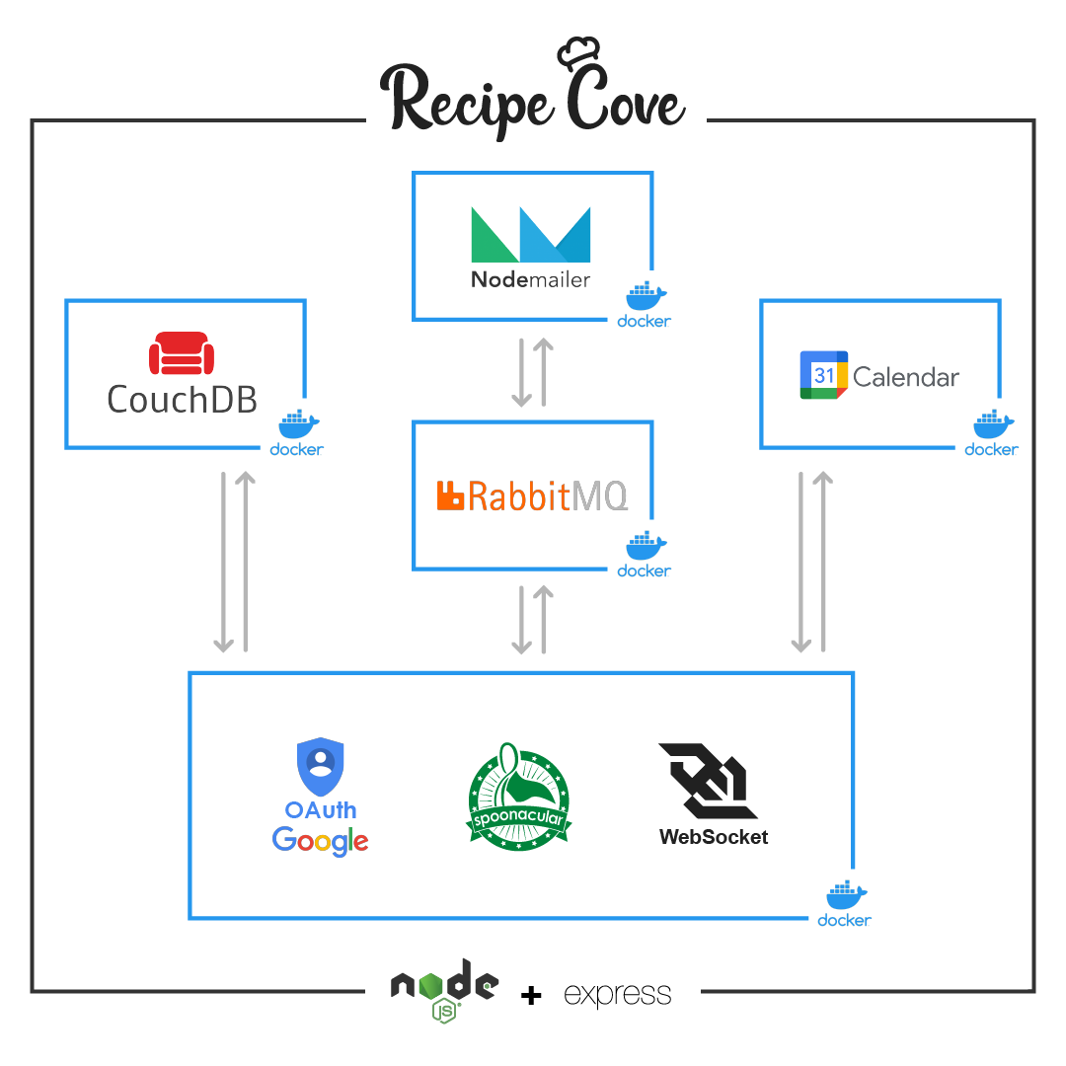

# 3 Deployment

Docker Compose makes it straightforward to build and deploy the entire application, through the use of the docker-compose.yaml file, which specifies all the services that compose the application, and how they interact and communicate with each other.

The docker-compose.yaml file specifies containers’ names, the ports that should be exposed, the build and volume directories, the dependencies and the networks used to communicate.

The deployment of the application itself is very simple, following these steps:

* Open a terminal
* Move to the folder which contains the application
* Execute the following command: docker-compose up -d –build
* Open on any browser the following link: https://localhost:3000

The command is used to first build the necessary images and then to run all the containers composing the application. As an alternative, we also provided a python script named recipe_cove_starter.py, which serves the same purpose.

Depending on the system used to run the application, the aforementioned command may require admin privileges to be executed: to overcome this, one should simply add the “sudo” string before the command or run the terminal as an administrator.

# 4 User Stories of the system

We identified a range of user stories which were relevant to the goals of our final system’s vision: they range from the search for recipes and their information to the creation of in-app artifacts, such as Calendars, reminders and a favorite list.

Additionally, we defined a set of more general system dependent user stories, in the form of registration of a new user, the login and logout functionalities ecc.

The following spreadsheet contains the data of all the user stories of our system:

| EPIC | USER STORY | PRIORITY | VALUE | RISK | ESTIMATE | RELEASE | ACCEPTANCE | DEPENDENCIES | NOTES |
| --- | --- | --- | --- | --- | --- | --- | --- | --- | --- |
| **Registration** | As a visitor, I want to be able to register in the website with an external account, so that I can use an existing Google account | 1 High | 1 High | 2 Med | LG | 1.x | Upon registering, the user will automatically be logged in the website, with the navbar reflecting the change by showing the updated info | Possession of a Google account | The user must accept Google Terms of Service and agree with the use of Google Calendar if he wants to interact with it directly in the website |
| **Search recipes** | As a visitor, I want to be able to search a recipe by its name, so that I can search only what interests me | 2 Med | 2 Med | 3 Med | MD | 3.x | The user will see a list of recipes matching the searched value | API service provider and related API Key | The user must avoid being too specific in the search terms since most recipes are particularly specific in their names |
| **Show Recipe Information** | As a visitor, I want to be able to see the information of a recipe, so that I can learn more about it | 2 Med | 1 High | 3 Med | LG | 3.x | The user will have specific information about the selected recipe, in the form of extended description of ingredients, instructions ecc | Depends on the user story in row #3 | The user should notice that each ingredient's card is interactive |
| **Show Ingredient Information** | As a visitor, I want to be able to see the information of an ingredient, so that I can know the details of each ingredient in a recipe | 4 Low | 3 Med | 4 Low | SM | 4.x | The user will see extended information about the selected ingredient | Depends on the user story in row #4 |  |
| **Suggest Recipes** | As a visitor, I want to be able to check the suggested recipes for a specific diet, so that I can be inspired in what to prepare each day | 3 Med | 2 Med | 2 Med | LG | 4.x | The user will receive messages from the Chat-BOT in an asynchronous way | API service provider and related API Key |  |
| **Login** | As a registered user, I want to be able to perform the login, so that I can access other system's functionalities | 2 Med | 1 High | 2 Med | MD | 1.x | The user will notice the change in the navbar reflecting that he is logged in the website | Depends on the user story in row #2 |  |
| **Logout** | As a registered user, I want to be able to perform the logout, so that I can leave my information within the website | 3 Med | 3 Med | 4 Low | SM | 1.x | The user will be redirected to the home page, noticing the possibility to login | Depends on the user story in row #7 |  |
| **Profile** | As a registered user, I want to be able to access my profile page, so that I can check my personal information | 1 High | 1 High | 2 Med | LG | 1.x | The user will see all of his information in a detailed page, including his account data as well as his favorites recipes and his calendar | Depends on the user story in row #2 and #7 | After the first registration, this page may be relatively empty so it is suggested that the user interacts a little bit with the system first |
| **Calendar Creation** | As a registered user, I want to be able to create a Calendar, so that I can populate it with events relating recipes | 2 Med | 2 Med | 1 High | XLG | 2.x | Upon clicking the add button, the user will see the newly created calendar in the profile page | Depends on the user story in row #2 and #7 | Since a number of API calls to the Google Calendar API needs to be done, as well as an interaction with the database, a small amount of time is needed in order to correctly visualize the calendar in the profile page |
| **Calendar Deletion** | As a registered user, I want to be able to delete a Calendar, so that I can remove the data gathered within the website | 3 Med | 3 Med | 4 Low | LG | 2.x | Upon clicking the delete button, the user will notice that the calendar will no longer be visible in the profile page | Depends on the user story in row #10 | As before, a small amount of time may be needed in order to properly update the profile page |
| **Add Event** | As a registered user, I want to be able to add an event to my Calendar, so that I can be reminded on a specific day to prepare a particular recipe | 1 High | 2 Med | 3 Med | MD | 3.x | After filling the required form information, the user will be redirected to his profile page and see the newly added event | Depends on the user story in row #10 and #4 | If the event is added for days not displayed in the current month, the user needs to scroll the various months of the calendar to check the new event |
| **Add Recipe to Favorites** | As a registered user, I want to be able to add a recipe to my favorite list, so that I can keep track of all the recipes I like | 2 Med | 1 High | 3 Med | MD | 4.x | When the user is logged in, after clicking on the button to add the current recipe to his favorite list, he can see his list updated correctly in his profile | Depends on the user story in row #7 and #4 | In order to provide the best navigation for the user, after he adds a recipe to his favorite list, he will not automatically be redirected to the profile, remaining at the current visited page |
| **Remove Recipe from Favorites** | As a registered user, I want to be able to remove a recipe from my favorite list, so that I can stop being interested in it | 4 Low | 3 Med | 4 Low | MD | 4.x | The user will see his favorite list automatically updated in his profile, with the selected recipe removed from the list | Depends on the user story in row #9 | It follows the same principles of the previous user story |
| **Show Favorites List** | As a registered user, I want to be able to see my favorite list, so that I can check my current interests in recipes | 2 Med | 1 High | 2 Med | SM | 4.x | Once entering the profile, the user will be able to correctly see the displayed favorite list, at the right-hand side of the page | Depends on the user story in row #9 |  |
| **Delete Account** | As a registered user, I want to be able to delete my personal account, so that I can remove everything related to it from the website | 2 Med | 2 Med | 2 Med | MD | 1.x | The user will automatically be redirected to the home page, in which he has the ability to register to the website again | Depends on the user story in row #9 | When deleting the account from the website, the user will not be automatically have the consent removed from the services he agreed before (Google account and Google Calendar). In order to do so, he has to enter his personal area in his Google account and remove the consents manually |
| **Mail Notification** | As a visitor, I want to be able to receive a mail notification when registering, so that I can know if the registration process has succeeded | 2 Med | 3 Med | 2 Med | LG | 5.x | The user will receive a mail to the Google account used to register in the system | Depends on the user story in row #2 | The user may not have the notifications activated for gmail, so in order to see the feedback he may directly enter the app and check the latest mails |

The following charts visually represent the values assigned to each user story. In particular we analyze the priority, value and risk metrics as well as the user story count and value provided for each software release.

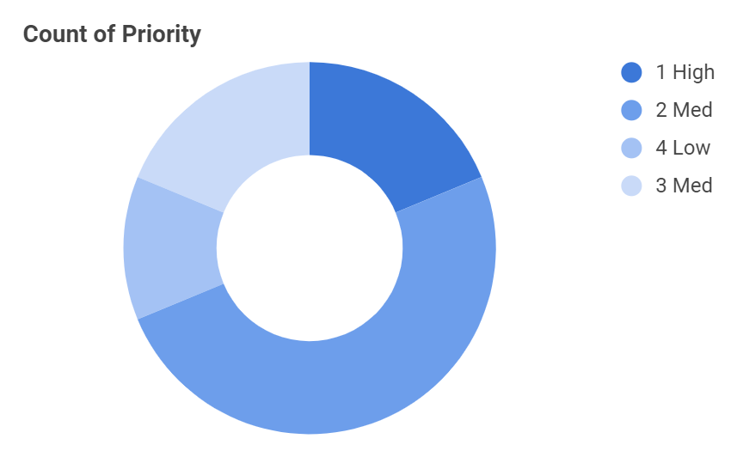

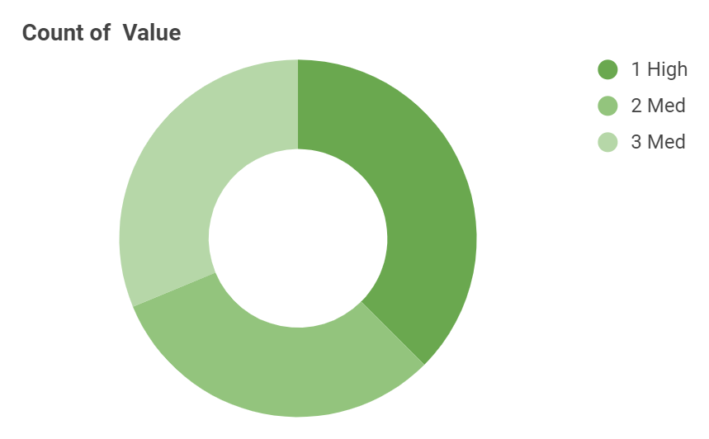

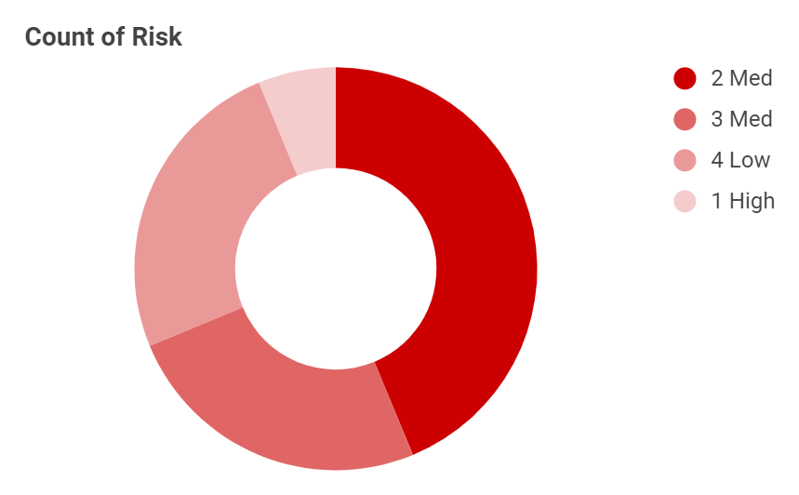

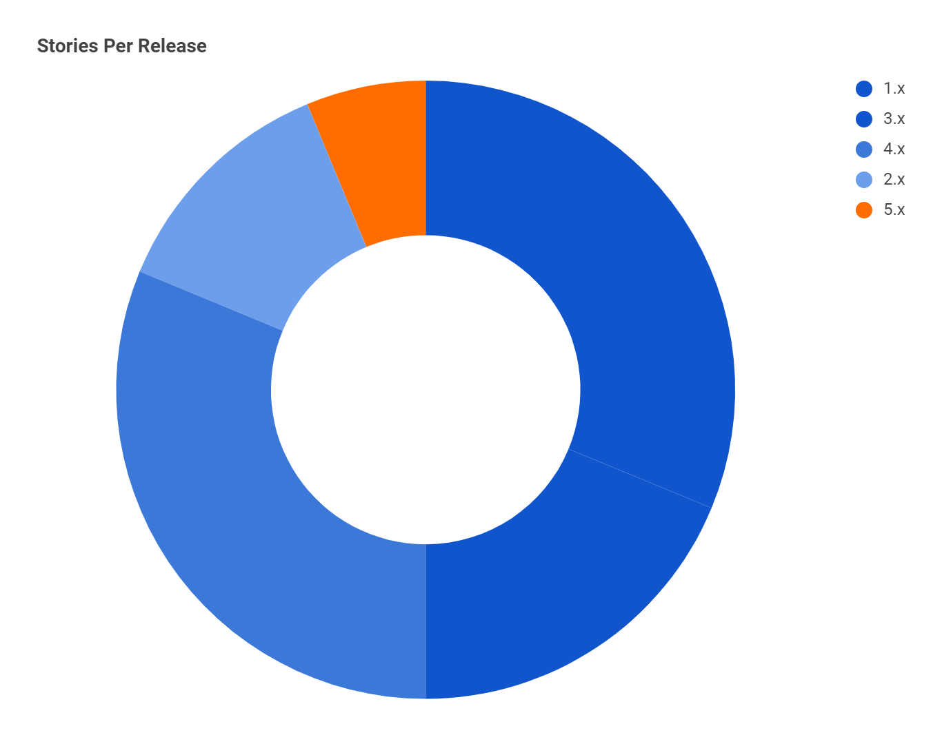

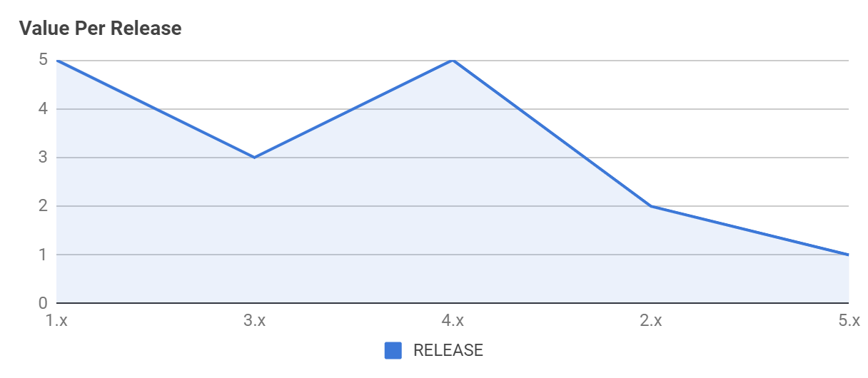

# 5 Mockups

In this section we present the original Mockups of our system, presenting for each page the relevant sections, buttons and elements.

In the following pages, for each Html page represented by a Mockup, we specify which user stories are met for each functionality to be implemented in the final system.

At the end of this section we also included a storyboard which clearly presents the connections between the pages and the user stories involved.

## 5.1 Home Page

From the Home page, the user has the ability to register/login to our system, he can use a Chat-BOT microservice to search recipes following a particular diet, or search them directly through the use of a search bar.

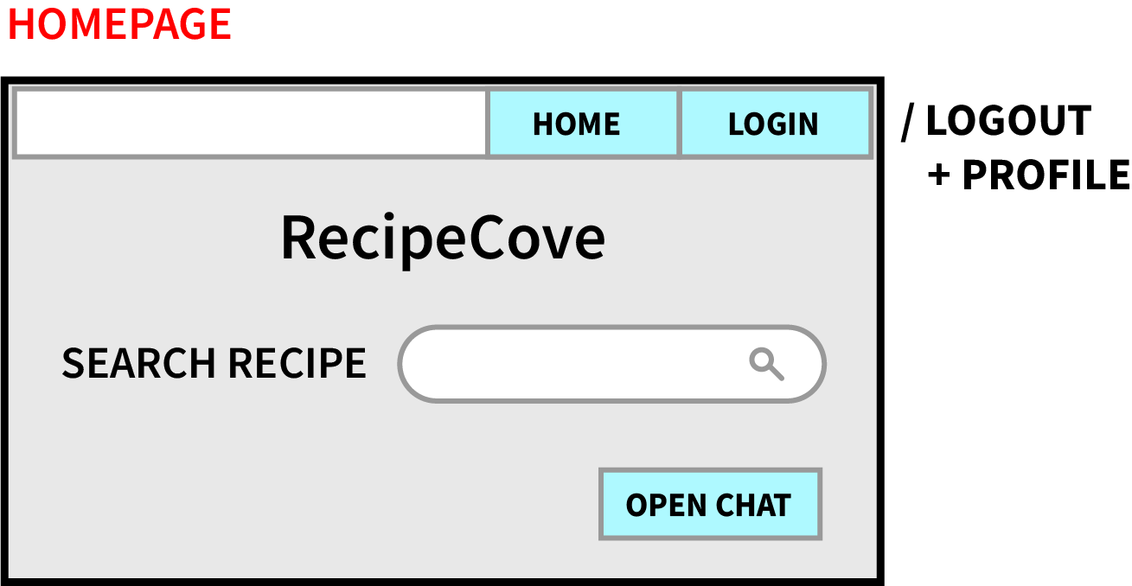

1. As a visitor, I want to be able to register in the website with an external account, so that I can use an existing Google account
2. As a visitor, I want to be able to search a recipe by its name, so that I can search only what interests me
3. As a visitor, I want to be able to check the suggested recipes for a specific diet, so that I can be inspired in what to prepare each day
4. As a registered user, I want to be able to perform the login, so that I can access other system's functionalities
5. As a registered user, I want to be able to perform the logout, so that I can leave my information within the website
6. As a registered user, I want to be able to access my profile page, so that I can check my personal information

## 5.2 Search Results Page

From the search results page, it is possible to see all the results in accordance to the search terms inserted and it is possible to click on each result to be prompted to the Recipe Page, which contains all the relevant information of the selected recipe.

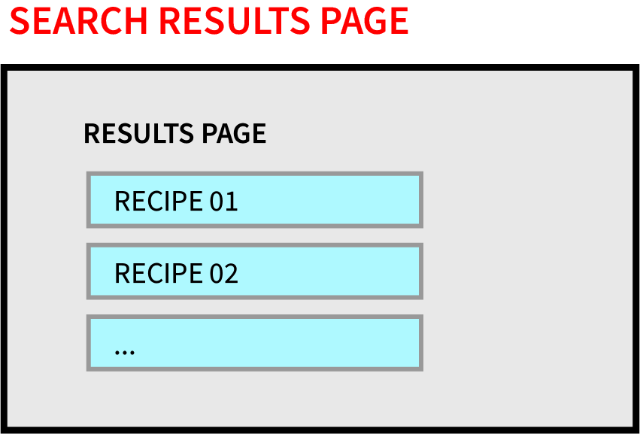

1. As a visitor, I want to be able to search a recipe by its name, so that I can search only what interests me
2. As a visitor, I want to be able to see the information of a recipe, so that I can learn more about it

## 5.3 Recipe Page

In the Recipe Page it is possible to check all of its information, including its ingredients, as well as put it in the user’s favorite list and create reminders for the user’s calendar.

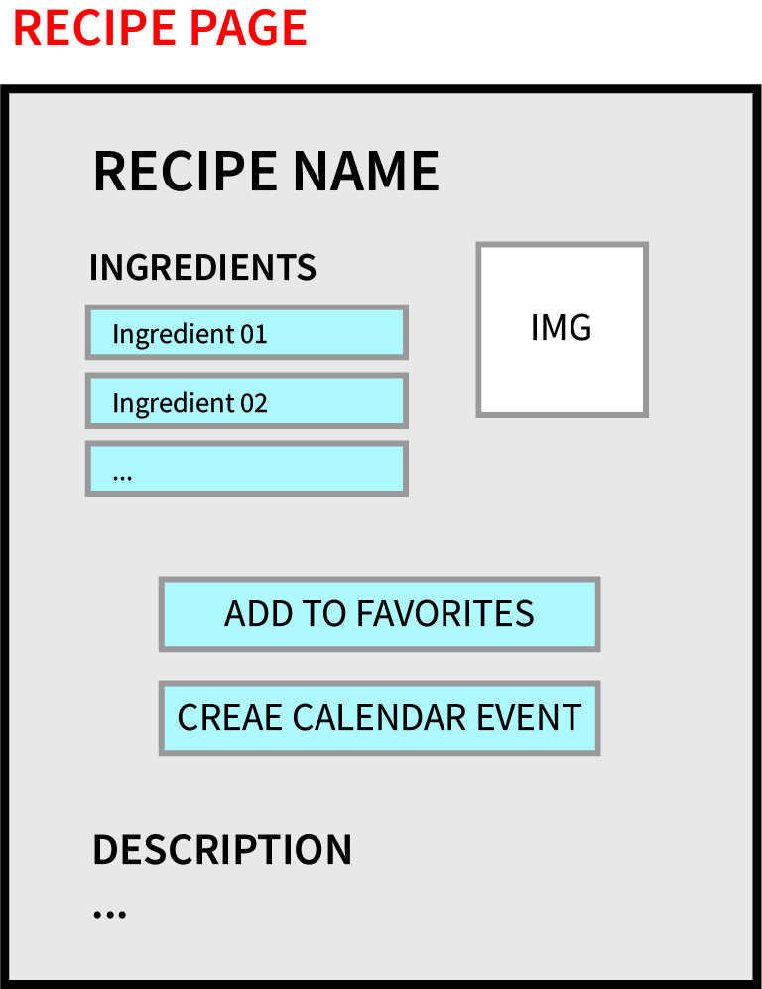

1. As a visitor, I want to be able to see the information of a recipe, so that I can learn more about it
2. As a visitor, I want to be able to see the information of an ingredient, so that I can know the details of each ingredient in a recipe
3. As a registered user, I want to be able to add an event to my Calendar, so that I can be reminded on a specific day to prepare a particular recipe
4. As a registered user, I want to be able to add a recipe to my favorite list, so that I can keep track of all the recipes I like

## 5.4 Ingredient Page

The purpose of the ingredient page is to visualize the most relevant information about the ingredients used in a particular recipe, ranging from the percentage of proteins, fats and carbs, to the nutritional values of the ingredient.

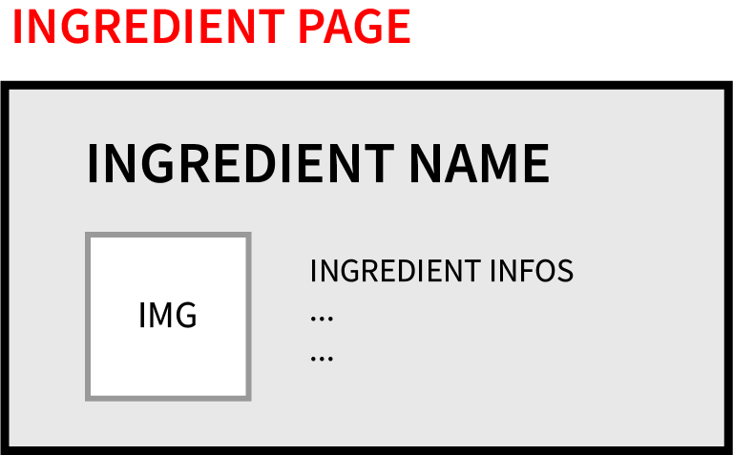

1. As a visitor, I want to be able to see the information of an ingredient, so that I can know the details of each ingredient in a recipe

## 5.5 User Profile Page

This page gathers the information of the registered user, including his account info, favorite recipes list and personal calendar. From this page it is possible to create or delete a calendar, and to remove specific recipes from the favorite list. The user can additionally delete his account.

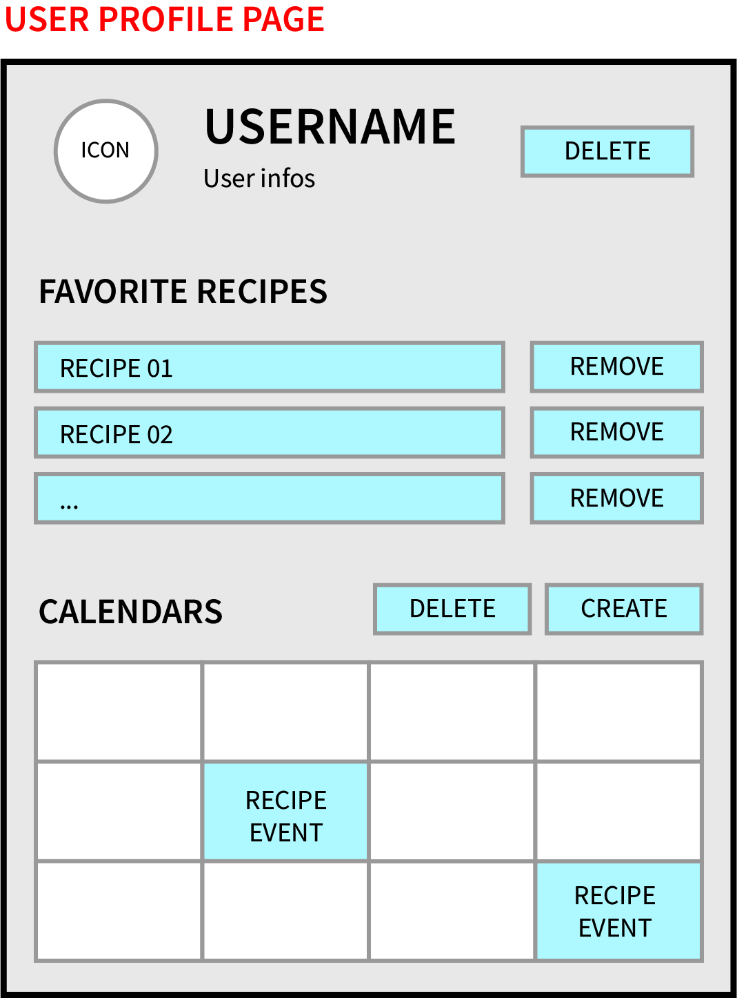

1. As a registered user, I want to be able to access my profile page, so that I can check my personal information
2. As a registered user, I want to be able to create a Calendar, so that I can populate it with events relating recipes
3. As a registered user, I want to be able to delete a Calendar, so that I can remove the data gathered within the website
4. As a registered user, I want to be able to remove a recipe from my favorite list, so that I can stop being interested in it
5. As a registered user, I want to be able to see my favorite list, so that I can check my current interests in recipes

## 5.6 Recipe Calendar Event

This page is used to allow the user to fill in all the details that he wants to include in a new event for his calendar. The information to fill should include the description of the reminder, the start and end dates as well as the displayed color palette for the event.

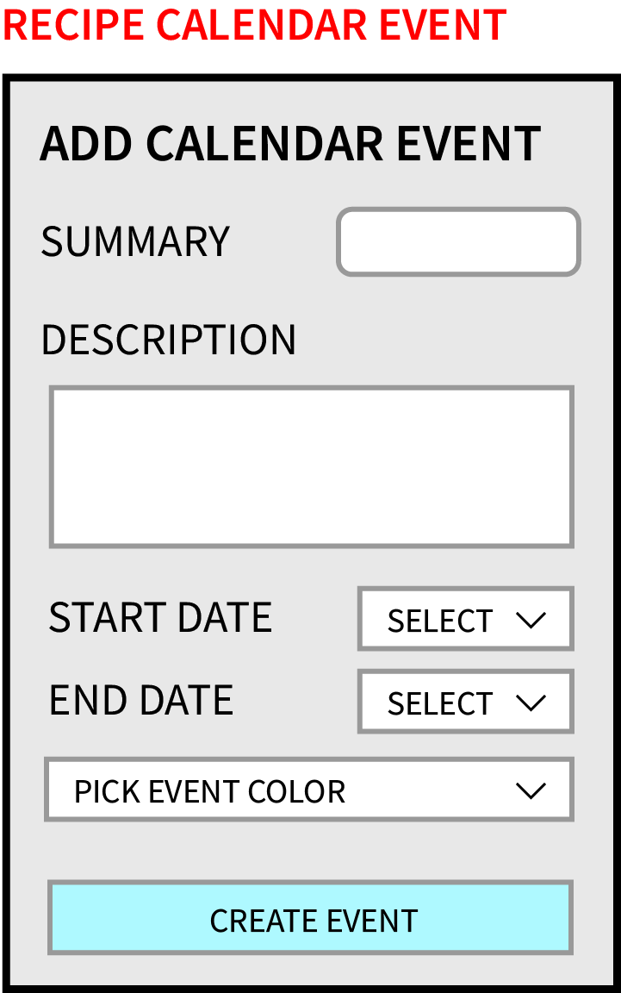

1. As a registered user, I want to be able to add an event to my Calendar, so that I can be reminded on a specific day to prepare a particular recipe

## 5.7 Chat-BOT (Menu)

Instead of being a standalone page, the Chat-BOT functionality should be presented to the user as an overlay Menu, placed at the bottom of the Home Page. This Menu should suggest a recipe based on the user's diet interests.

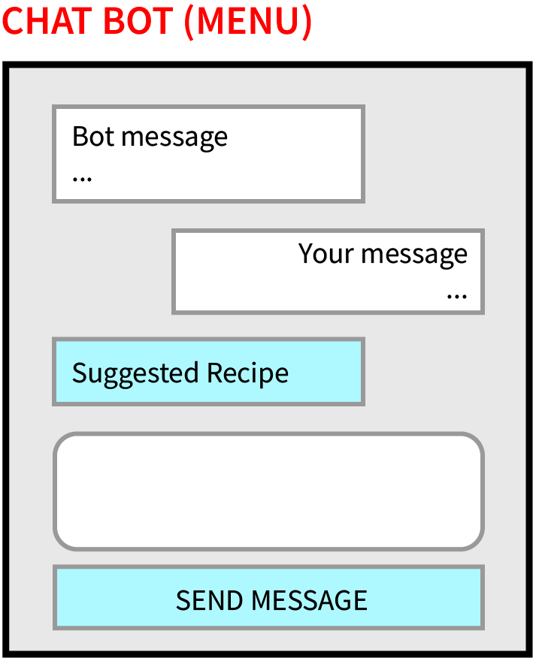

1. As a visitor, I want to be able to check the suggested recipes for a specific diet, so that I can be inspired in what to prepare each day

## 5.8 Storyboard

In this section we present the storyboard, which includes all the Mockups and user stories. It should allow the reader to clearly follow the interactions with the links and buttons of the system, while also keeping in mind which user stories are involved in each interaction.

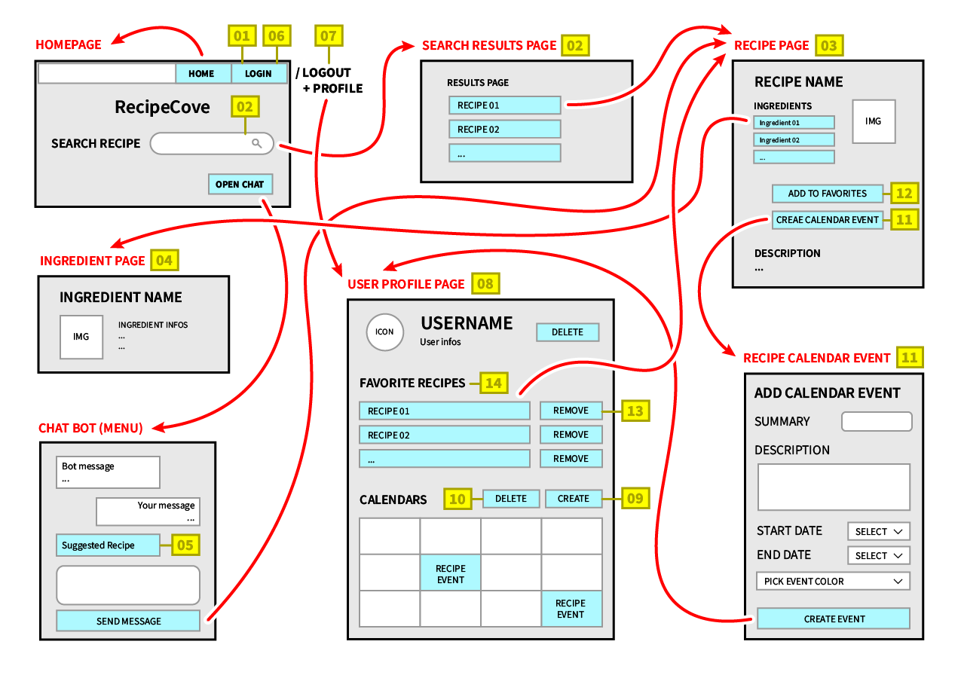

# 6 Function Points Estimation and COCOMO II

In this section we summarize all the results and findings we gathered with the use of specific spreadsheets to estimate the Function Points for our system as well as the effort, time and cost that is needed to complete the project with the COCOMO II method.

## 6.1 Function Points

For the estimation of Function Points, it is needed to analyze the interaction with both the user and other applications.

The system component interacting with the user is the web interface, by allowing the user to register a new account and to login, create a new calendar and add a new event directly in the system.

On the other hand, the interaction with other applications consists mainly in the exchange of data needed for the Google Calendar API as well as the Spoonacular API, used to search, organize and show the recipes and their information. Additionally, there is the interaction with the RabbitMQ service used to send an email to the user that registers in the system.

CouchDB is the database used to store the users’ information, in a table containing the data which is modified periodically by the application and which is maintained within the application’s boundaries.

Other data which is instead referenced by the application and maintained within the boundaries of another, external application are the Google account information, the recipes and ingredients information.

All the estimations for the Function Points (FP) has been done through the use of a specialized Excel sheet. However, since we adopt the Cocomo II method to adjust the FPs, we ignore the adjustment done by the sheet, which considers the Value Added Factor (or Value Adjustment Factor, VAF) instead.

Thus, starting from the definition of the Internal Logical Files (ILF) and External Interface Files (EIF), we identified:

* An ILF for the users, with 1 RET and 10 DET (id, name, given name, family name, link, picture, gender, locale, favorites list, calendar information) ⇒ 7FP
* An EIF for the google account information, with 1 RET and 8 DET ⇒ 5FP
* An EIF for the recipes information, with 1 RET and 7 DET ⇒ 5FP
* An EIF for the ingredient information, with 1 RET and 8 DET ⇒ 5FP

The total amount of Function Points for all the ILF and EIF is 7+5+5+5=22 FP.

The data coming from outside the application boundaries mainly includes the registration process of a new user, the management of a calendar and the data pertinent to the recipes and ingredients. We therefore identified the following External Inputs (EI):

* An EI for inserting a new user, with 2 FTR and 10 DET ⇒ 4FP
* An EI for the login of a user, with 1 FTR and 1 DET ⇒ 3FP
* An EI for deleting a user, with 1 FTR and 10 DET ⇒ 3FP
* An EI for creating a new calendar for a user, with 1 FTR and 1 DET ⇒ 3FP
* An EI for deleting a calendar for a user, with 1 FTR and 1 DET ⇒ 3FP
* An EI for adding a recipe to the favorite list, with 1 FTR and 1 DET ⇒ 3FP
* An EI for deleting a recipe from the favorite list, with 1 FTR and 1 DET ⇒ 3FP

The total amount of function points for all EI is 4+3+3+3+3+3+3=22 FP.

For the data sent outside the application boundaries, which modifies or alters an ILF, is composed mainly of the email sent to a registered user and the creation and visualization of an event inside a calendar. Thus we described these External Outputs (EO):

* An EO for preparing and sending an email to the registered user, with 1 FTR and 2 DET ⇒ 4FP
* An EO for adding an event to calendar and visualize it, with 1 FTR and 1 DET ⇒ 4FP

As far as the data sent outside the application boundaries, which however is not modified nor provides derived data, it consists of the visualization of the user information, as well as recipes and ingredients information. We identified the following External Inquiries (EQ):

* An EQ for the visualization of the profile of a user, with 2 FTR and 7 DET ⇒ 4FP
* An EQ for the visualization of the favorite list of a user, with 1 FTR and 1 DET ⇒ 3FP
* An EQ for the visualization of a recipe’s information, with 1 FTR and 7 DET ⇒ 3FP
* An EQ for the visualization of an ingredient’s information, with 1 FTR and 8 DET ⇒ 3FP

The total amount of function points for all EO and EQ is 4+4+4+3+3+3=21 FP.

The final amount of FP for our system is 22+22+21=65 FP.

All these computations have been obtained with the Excel sheets presented at the end of this section.

## 6.2 COCOMO II

With the data previously obtained, we can carry out the COCOMO II estimation to see how much effort, time and cost is needed to complete the project.

By inserting all the necessary fields in the online calculator (at the link: <http://softwarecost.org/tools/COCOMO/>) we obtained the following results:

* it should require us approximately 3445 SLOC
* it should be scheduled for 5.3 months
* the effort required should be 6.1 person-month
* the overall cost (considering the cost per person-month as 2400) would be $14612

The corresponding values inserted to carry out the previous evaluation are the following:

| startCOCOMO, 1  MonteCarlo, MonteCarlo_Off  AutoCalculate, On  size_type, Function Points  function_points, 65  language, Java  prec, Very_High  flex, Low  rely, Nominal  data, Low  cplx, Low  ruse, High  docu, Nominal  resl, Nominal  team, Extra_High  acap, Nominal  pcap, High  pcon, High  apex, High  pexp, Nominal  ltex, Nominal  pmat, Low  time, High  stor, Nominal  pvol, Low  tool, Nominal  site, Very_High  sced, Low  software_maintenance, Off  software_labor_cost_per_PM, 2400  software_EAF, 0.55  size_exponent, 1.0677  schedule_exponent, 0.312  software_effort, 6.1  software_schedule, 5.3 |
| --- |

## 6.3 Adopted Excel Sheets

In this final subsection, we report the Excel sheets that have been used for the previous estimation.

The first sheet presented was used to insert data about our system’s functionalities and to obtain an estimate on the total amount of Function Points:

|  |  |  |  |  |  |  |  |  |  |  |  |
| --- | --- | --- | --- | --- | --- | --- | --- | --- | --- | --- | --- |
|  | **FUNCTION POINT CALCULATION** |  |  |  |  | Language | English |  | Adjusted FP | | **69,55** |
|  |  |  |  |  |  |  |  |  |  |  |  |
|  | No. | VAF | | Weight: 0 (low) ~ 5 (high) |  |  |  |  |  |  |  |
|  | 1 | Data communications | | 3 |  |  |  |  |  |  |  |
|  | 2 | Distributed data processing | | 3 |  |  |  |  |  |  |  |
|  | 3 | Performance |  | 3 |  |  |  |  |  |  |  |
|  | 4 | Heavily used configuration | | 3 |  | FP: | Function Point |  |  |  |  |
|  | 5 | Transaction rate |  | 3 |  | VAF: | Value Added Factor |  |  |  |  |
|  | 6 | On-Line data entry | | 3 |  | DET: | Data Element Type |  |  |  |  |
|  | 7 | End-user efficiency | | 3 |  | RET: | Record Element Type |  |  |  |  |
|  | 8 | On-Line update |  | 3 |  | FTR: | File Types Referenced |  |  |  |  |
|  | 9 | Complex processing | | 3 |  | ILF: | Internal Logical Files |  |  |  |  |
|  | 10 | Reusability |  | 3 |  | EIF: | External Interface Files |  |  |  |  |
|  | 11 | Installation ease |  | 3 |  | EI: | External Inputs |  |  |  |  |
|  | 12 | Operational ease |  | 3 |  | EO: | External Outputs |  |  |  |  |
|  | 13 | Multiple sites |  | 3 |  | EQ: | External Inquiry |  |  |  |  |
|  | 14 | Facilitate change |  | 3 |  |  |  |  |  |  |  |
|  |  |  |  | 42 |  |  |  |  |  |  |  |
|  |  |  |  |  |  |  |  |  |  |  |  |
|  |  |  |  |  |  |  |  |  | Unadjusted FP | | **65** |

| **No.** | **Module** | **Function Name** | **Description** | **Type** | **DET** | **RET / FTR** | **Complexity** | **FP** | **Adjust %** | **FP adjusted** |
| --- | --- | --- | --- | --- | --- | --- | --- | --- | --- | --- |
| 1 | User | Users information | Information about the users | ILF | 10 | 1 | Low | 7 |  | **7** |
| 2 | Google account | Google account information | Information about the Google account | EIF | 8 | 1 | Low | 5 |  | **5** |
| 3 | Recipe | Recipes information | Information about the recipes | EIF | 7 | 1 | Low | 5 |  | **5** |
| 4 | Ingredient | Ingredients information | Information about the ingredients | EIF | 8 | 1 | Low | 5 |  | **5** |
| 5 | User | Insert User | Insert a new user into the database | EI | 10 | 2 | Average | 4 |  | **4** |
| 6 | User | Login User | Login the user into the system | EI | 1 | 1 | Low | 3 |  | **3** |
| 7 | User | Delete User | Delete the user from the database | EI | 10 | 1 | Low | 3 |  | **3** |
| 8 | Calendar | Create Calendar | Create a new Calendar for a user | EI | 1 | 1 | Low | 3 |  | **3** |
| 9 | Calendar | Delete Calendar | Delete a Calendar for a User | EI | 1 | 1 | Low | 3 |  | **3** |
| 10 | Recipe | Add Recipe to favorites | Add a Recipe to the favorites list | EI | 1 | 1 | Low | 3 |  | **3** |
| 11 | Recipe | Remove Recipe from favorites | Remove a Recipe from the favorites list | EI | 1 | 1 | Low | 3 |  | **3** |
| 12 | User | Send Mail | The system sends a confirmation email to the User the registers | EO | 2 | 1 | Low | 4 |  | **4** |
| 13 | Calendar | Add Event to Calendar | Add a new Event to a Calendar | EO | 1 | 1 | Low | 4 |  | **4** |
| 14 | User | Display User Profile | Visualize the Profile of a User | EQ | 7 | 2 | Average | 4 |  | **4** |
| 15 | User | Display Favorite List | Visualize the favorite list of a User | EQ | 1 | 1 | Low | 3 |  | **3** |
| 16 | Recipe | Display Recipes information | Visualize a Recipe's information | EQ | 7 | 1 | Low | 3 |  | **3** |
| 17 | Ingredient | Display Ingredients information | Visualize a Ingredient's information | EQ | 8 | 1 | Low | 3 |  | **3** |

The following represents instead the computation for the effort, time and cost estimation for our project, obtained with the use of the COCOMO II method:

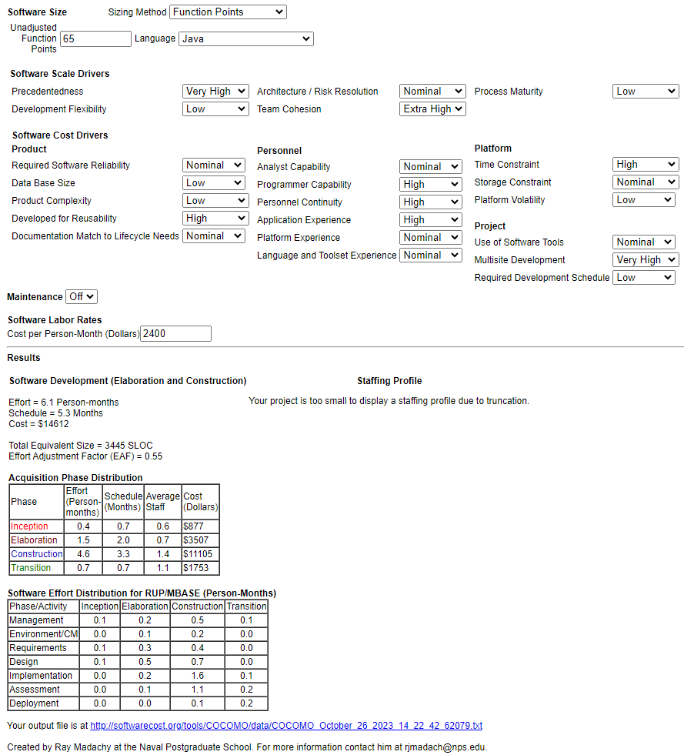

# 7 Development Process - Scrum & Sprint Reports

## 7.1 SCRUM

At the base of the development process for our project we employed the SCRUM methodology.

SCRUM allows the developers’ team to focus on delivering the highest business value in the shortest possible time, in an agile process.

With this idea in mind, we organized ourselves in order to deliver the highest priority features in the best way, allowing us to obtain each time a real working software that could potentially be delivered as it is.

The work for the system has been organized into 6 total “sprints”, with the first being concentrated on the requirement gathering phase and organization of the whole system, and the remaining focused on the actual software implementation.

The people working on this project were assigned specific roles in the following way:

* Valerio Di Stefano (1898728) had been assigned the role of the Product owner: he had the task to define the features of the final product, decide the release dates and adjust the features and their priorities at each iteration (in fact he is the one who mainly designed the initial documentation)
* Giuseppe Prisco (1895709) had been assigned the role of Scrum Master: he had the responsibility to manage the project and enforce Scrum values and practices throughout the development phases. Additionally, he had the task to remove any impediments that may have arisen and ensure that the team was fully functional and productive, while ensuring close cooperation between all the roles and functions
* The team is composed of the two people working on the project, Valerio Di Stefano (1898728) and Giuseppe Prisco (1895709). The team is cross-functional, meaning that each member is specialized in different functions, while covering all the ones that are needed for the final system implementation. We ensured that all the team members were full-time and self-organized throughout the development phases

The following charts are devoted to provide a clear understanding on the organization of the whole project, presenting a Gantt chart, which starts from the Work Breakdown Structure (WBS) and provides estimations on the amount of work to be done as well as starting and ending date for each item of the WBS, a Burndown chart, to visually present the working trend throughout the software life cycle, and the Sprint adopted during the development process.

### 7.1.1 Gantt Chart

The following is the Excel sheet containing the WBS of the project:

| **WORK BREAKDOWN STRUCTURE** | **TASK TITLE** | **TASK OWNER** | **AMOUNT OF WORK IN HOURS** | | | **SPRINT** | **START DATE** | **DUE DATE** | **DURATION** | **PCT OF TASK COMPLETE** |
| --- | --- | --- | --- | --- | --- | --- | --- | --- | --- | --- |
| **ESTIMATE** | **COMPLETED** | **REMAINING** |
| 1 | Project Conception and Documentation |  | 56 | 56 | 0 |  |  |  |  | **100%** |
| 1.1 | Project Functionalities | V | 10 | 10 | 0 | 1 | 9/20/2023 | 9/23/2023 | 4 | **100%** |
| 1.2 | User Stories | V | 10 | 10 | 0 | 1 | 9/23/2023 | 9/25/2023 | 3 | **100%** |
| 1.3 | LoFi Mockups | V | 12 | 12 | 0 | 1 | 9/25/2023 | 9/29/2023 | 5 | **100%** |
| 1.4 | Function Points Estimate | G | 8 | 8 | 0 | 1 | 9/25/2023 | 9/26/2023 | 2 | **100%** |
| 1.5 | COCOMO II | G | 7 | 7 | 0 | 1 | 9/27/2023 | 9/29/2023 | 3 | **100%** |
| 1.6 | ER schema | V | 4 | 4 | 0 | 2 | 9/29/2023 | 9/29/2023 | 1 | **100%** |
| 1.7 | Software architecture schema | V | 5 | 5 | 0 | 2 | 9/30/2023 | 10/1/2023 | 2 | **100%** |
| 2 | System Configuration and Basic Functionalities |  | 37 | 37 | 0 |  |  |  |  | **100%** |
| 2.1 | Registration with a Google Account | G | 12 | 12 | 0 | 2 | 10/1/2023 | 10/4/2023 | 4 | **100%** |
| 2.2 | Login | G | 6 | 6 | 0 | 2 | 10/4/2023 | 10/5/2023 | 2 | **100%** |
| 2.3 | Logout | G | 3 | 3 | 0 | 2 | 10/5/2023 | 10/5/2023 | 1 | **100%** |
| 2.4 | Delete Account | G | 6 | 6 | 0 | 2 | 10/6/2023 | 10/7/2023 | 2 | **100%** |
| 2.5 | Profile | G | 10 | 10 | 0 | 2 | 10/8/2023 | 10/10/2023 | 3 | **100%** |
| 3 | Development of Core Functionalities |  | 54 | 54 | 0 |  |  |  |  | **100%** |
| 3.1 | Create Calendar | G | 16 | 16 | 0 | 3 | 10/11/2023 | 10/14/2023 | 4 | **100%** |
| 3.2 | Delete Calendar | G | 12 | 12 | 0 | 3 | 10/14/2023 | 10/16/2023 | 3 | **100%** |
| 3.3 | Search Recipes | V | 8 | 8 | 0 | 4 | 10/17/2023 | 10/18/2023 | 2 | **100%** |
| 3.4 | Show Recipes Information | V | 12 | 12 | 0 | 4 | 10/18/2023 | 10/21/2023 | 4 | **100%** |
| 3.5 | Add Event to Calendar | G | 6 | 6 | 0 | 4 | 10/18/2023 | 10/19/2023 | 2 | **100%** |
| 4 | Development of additional minor Functionalities |  | 20 | 20 | 0 |  |  |  |  | **100%** |
| 4.1 | Show Ingredient Information | V | 4 | 4 | 0 | 5 | 10/22/2023 | 10/23/2023 | 2 | **100%** |
| 4.2 | Suggest Recipes | G | 8 | 8 | 0 | 5 | 10/22/2023 | 10/24/2023 | 3 | **100%** |
| 4.3 | Add Recipe to Favorites | V | 4 | 4 | 0 | 5 | 10/23/2023 | 10/23/2023 | 1 | **100%** |
| 4.4 | Remove Recipe from Favorites | V | 3 | 3 | 0 | 5 | 10/24/2023 | 10/24/2023 | 1 | **100%** |
| 4.5 | Show Favorite Recipes | V | 1 | 1 | 0 | 5 | 10/24/2023 | 10/24/2023 | 1 | **100%** |
| 5 | Finalization of the Project |  | 23 | 23 | 0 |  |  |  |  | **100%** |
| 5.1 | Mail Notification | V | 12 | 12 | 0 | 6 | 10/25/2023 | 10/27/2023 | 3 | **100%** |
| 5.2 | GUI for Home, profile, recipes, ingredients page | V | 7 | 7 | 0 | 6 | 10/27/2023 | 10/28/2023 | 2 | **100%** |
| 5.3 | GUI for add event to calendar and error page | G | 4 | 4 | 0 | 6 | 10/27/2023 | 10/28/2023 | 2 | **100%** |

Here we present instead the organization of the work done each day, for the whole duration of the project:

| **WEEK 1** | | | | | **WEEK 2** | | | | | **WEEK 3** | | | | | **WEEK 4** | | | | | **WEEK 5** | | | | | **WEEK 6** | | | | |
| --- | --- | --- | --- | --- | --- | --- | --- | --- | --- | --- | --- | --- | --- | --- | --- | --- | --- | --- | --- | --- | --- | --- | --- | --- | --- | --- | --- | --- | --- |
| **M** | **T** | **W** | **R** | **F** | **M** | **T** | **W** | **R** | **F** | **M** | **T** | **W** | **R** | **F** | **M** | **T** | **W** | **R** | **F** | **M** | **T** | **W** | **R** | **F** | **M** | **T** | **W** | **R** | **F** |
|  |  |  |  |  |  |  |  |  |  |  |  |  |  |  |  |  |  |  |  |  |  |  |  |  |  |  |  |  |  |
|  |  |  |  |  |  |  |  |  |  |  |  |  |  |  |  |  |  |  |  |  |  |  |  |  |  |  |  |  |  |
|  |  |  |  |  |  |  |  |  |  |  |  |  |  |  |  |  |  |  |  |  |  |  |  |  |  |  |  |  |  |
|  |  |  |  |  |  |  |  |  |  |  |  |  |  |  |  |  |  |  |  |  |  |  |  |  |  |  |  |  |  |
|  |  |  |  |  |  |  |  |  |  |  |  |  |  |  |  |  |  |  |  |  |  |  |  |  |  |  |  |  |  |
|  |  |  |  |  |  |  |  |  |  |  |  |  |  |  |  |  |  |  |  |  |  |  |  |  |  |  |  |  |  |
|  |  |  |  |  |  |  |  |  |  |  |  |  |  |  |  |  |  |  |  |  |  |  |  |  |  |  |  |  |  |
|  |  |  |  |  |  |  |  |  |  |  |  |  |  |  |  |  |  |  |  |  |  |  |  |  |  |  |  |  |  |
|  |  |  |  |  |  |  |  |  |  |  |  |  |  |  |  |  |  |  |  |  |  |  |  |  |  |  |  |  |  |
|  |  |  |  |  |  |  |  |  |  |  |  |  |  |  |  |  |  |  |  |  |  |  |  |  |  |  |  |  |  |
|  |  |  |  |  |  |  |  |  |  |  |  |  |  |  |  |  |  |  |  |  |  |  |  |  |  |  |  |  |  |
|  |  |  |  |  |  |  |  |  |  |  |  |  |  |  |  |  |  |  |  |  |  |  |  |  |  |  |  |  |  |
|  |  |  |  |  |  |  |  |  |  |  |  |  |  |  |  |  |  |  |  |  |  |  |  |  |  |  |  |  |  |
|  |  |  |  |  |  |  |  |  |  |  |  |  |  |  |  |  |  |  |  |  |  |  |  |  |  |  |  |  |  |
|  |  |  |  |  |  |  |  |  |  |  |  |  |  |  |  |  |  |  |  |  |  |  |  |  |  |  |  |  |  |
|  |  |  |  |  |  |  |  |  |  |  |  |  |  |  |  |  |  |  |  |  |  |  |  |  |  |  |  |  |  |
|  |  |  |  |  |  |  |  |  |  |  |  |  |  |  |  |  |  |  |  |  |  |  |  |  |  |  |  |  |  |
|  |  |  |  |  |  |  |  |  |  |  |  |  |  |  |  |  |  |  |  |  |  |  |  |  |  |  |  |  |  |
|  |  |  |  |  |  |  |  |  |  |  |  |  |  |  |  |  |  |  |  |  |  |  |  |  |  |  |  |  |  |
|  |  |  |  |  |  |  |  |  |  |  |  |  |  |  |  |  |  |  |  |  |  |  |  |  |  |  |  |  |  |
|  |  |  |  |  |  |  |  |  |  |  |  |  |  |  |  |  |  |  |  |  |  |  |  |  |  |  |  |  |  |
|  |  |  |  |  |  |  |  |  |  |  |  |  |  |  |  |  |  |  |  |  |  |  |  |  |  |  |  |  |  |
|  |  |  |  |  |  |  |  |  |  |  |  |  |  |  |  |  |  |  |  |  |  |  |  |  |  |  |  |  |  |
|  |  |  |  |  |  |  |  |  |  |  |  |  |  |  |  |  |  |  |  |  |  |  |  |  |  |  |  |  |  |
|  |  |  |  |  |  |  |  |  |  |  |  |  |  |  |  |  |  |  |  |  |  |  |  |  |  |  |  |  |  |
|  |  |  |  |  |  |  |  |  |  |  |  |  |  |  |  |  |  |  |  |  |  |  |  |  |  |  |  |  |  |
|  |  |  |  |  |  |  |  |  |  |  |  |  |  |  |  |  |  |  |  |  |  |  |  |  |  |  |  |  |  |
|  |  |  |  |  |  |  |  |  |  |  |  |  |  |  |  |  |  |  |  |  |  |  |  |  |  |  |  |  |  |
|  |  |  |  |  |  |  |  |  |  |  |  |  |  |  |  |  |  |  |  |  |  |  |  |  |  |  |  |  |  |
|  |  |  |  |  |  |  |  |  |  |  |  |  |  |  |  |  |  |  |  |  |  |  |  |  |  |  |  |  |  |

| **DAY** | **1** | **2** | **3** | **4** | **5** | **6** | **7** | **8** | **9** | **10** | **11** | **12** | **13** | **14** | **15** | **16** | **17** | **18** | **19** | **20** | **21** | **22** | **23** | **24** | **25** | **26** | **27** | **28** | **29** | **30** |
| --- | --- | --- | --- | --- | --- | --- | --- | --- | --- | --- | --- | --- | --- | --- | --- | --- | --- | --- | --- | --- | --- | --- | --- | --- | --- | --- | --- | --- | --- | --- |
| **PLAN** | 190 | 184 | 177 | 171 | 165 | 158 | 152 | 146 | 139 | 133 | 127 | 120 | 114 | 108 | 101 | 95 | 89 | 82 | 76 | 70 | 63 | 57 | 51 | 44 | 38 | 32 | 25 | 19 | 13 | 6 |
| **ESTIMATE** | 190 | 190 | 190 | 186 | 182 | 179 | 169 | 160 | 152 | 144 | 134 | 125 | 121 | 114 | 107 | 104 | 101 | 97 | 90 | 83 | 76 | 69 | 65 | 55 | 47 | 43 | 33 | 23 | 19 | 9 |
| **HRS COMPLETED** |  |  | 4 | 4 | 3 | 10 | 9 | 8 | 8 | 10 | 9 | 4 | 7 | 7 | 3 | 3 | 4 | 7 | 7 | 7 | 7 | 4 | 10 | 8 | 4 | 10 | 10 | 4 | 10 | 9 |
| **HRS REMAINING** | 190 | 190 | 186 | 182 | 179 | 169 | 160 | 152 | 144 | 134 | 125 | 121 | 114 | 107 | 104 | 101 | 97 | 90 | 83 | 76 | 69 | 65 | 55 | 47 | 43 | 33 | 23 | 19 | 9 | 0 |

### 7.1.2 Burndown chart

The following is the Burndown chart which shows how many hours of work have been done each day and how they compare to the planned and estimated values.

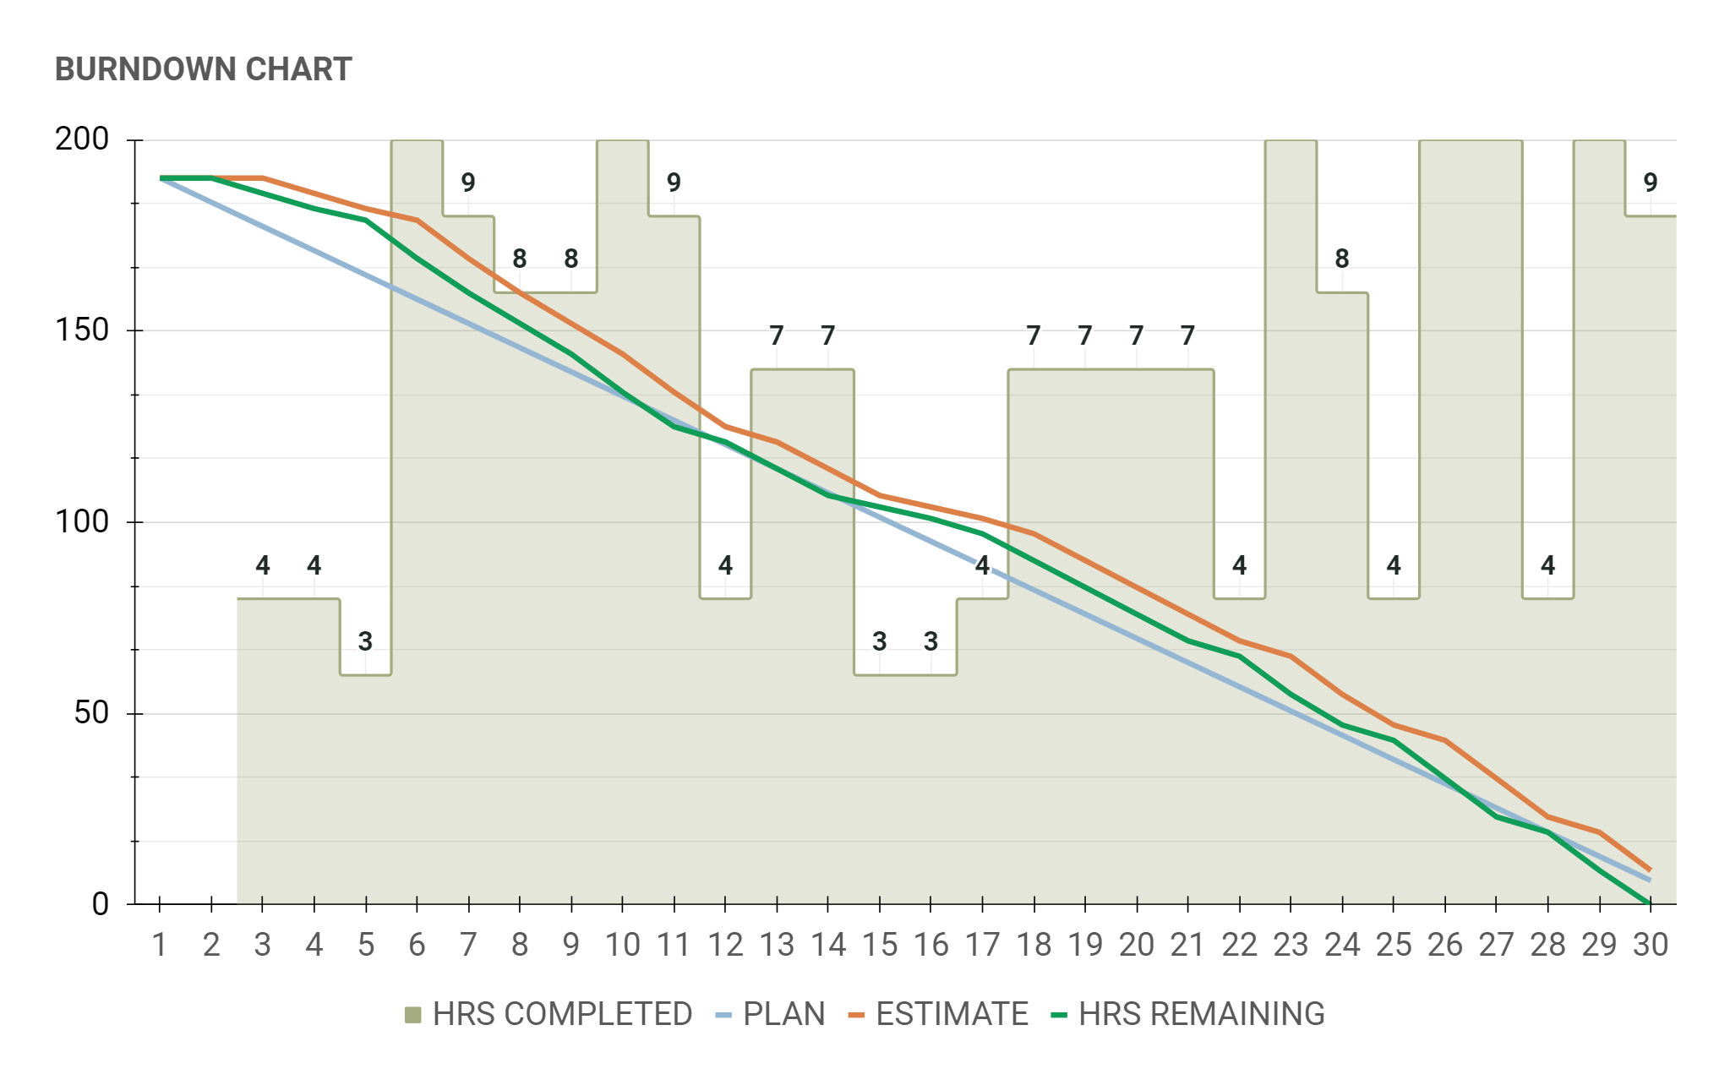

### 7.1.3 Release Backlog

Additionally, we also included the release backlog, containing all the product features which are to be completed within a release cycle:

| **PRIORITY** | **SPRINT** | **FUNCTIONALITY** | **TASK TITLE** | **TASK DESCRIPTION** | **TASK OWNER** | **WORK ESTIMATE IN HOURS** | **STATUS** |
| --- | --- | --- | --- | --- | --- | --- | --- |
| High | 1 | Project Conception and Documentation | Project Functionalities | Definition of the major functionalities of our project | V | **10** | Completed |
| High | 1 | Project Conception and Documentation | User Stories | Definition of the user stories of the system | V | **10** | Completed |
| Medium | 1 | Project Conception and Documentation | LoFi Mockups | Creation of the Low-Fidelity mockups of the the pages of our system | V | **12** | Completed |
| Medium | 1 | Project Conception and Documentation | Function Points Estimate | Estimation of the function points | G | **8** | Completed |
| Medium | 1 | Project Conception and Documentation | COCOMO II | Utilization of the COCOMO II method | G | **7** | Completed |
| Low | 2 | Project Conception and Documentation | ER schema | Creation of the ER-schema of our system | V | **4** | Completed |
| Low | 2 | Project Conception and Documentation | Software architecture schema | Creation of the schema of our system's architecture | V | **5** | Completed |
| High | 2 | System Configuration and Basic Functionalities | Registration with a Google Account | Creation of the functionality to register with a Google account in our system | G | **12** | Completed |
| Medium | 2 | System Configuration and Basic Functionalities | Login | Creation of the functionality to login in our system | G | **6** | Completed |
| Medium | 2 | System Configuration and Basic Functionalities | Logout | Creation of the functionality to logout from our system | G | **3** | Completed |
| Medium | 2 | System Configuration and Basic Functionalities | Delete Account | Managing the deletion of an account from the system | G | **6** | Completed |
| High | 2 | System Configuration and Basic Functionalities | Profile | Managing the information to be shown in the user profile | G | **10** | Completed |
| Medium | 3 | Development of Core Functionalities | Create Calendar | Creation of the functionality to create a Calendar directly in our system | G | **16** | Completed |
| Medium | 3 | Development of Core Functionalities | Delete Calendar | Creation of the functionality to delete a Calendar directly in our system | G | **12** | Completed |
| Medium | 4 | Development of Core Functionalities | Search Recipes | Creation of the functionality to search for recipes by name with an external API | V | **8** | Completed |
| Medium | 4 | Development of Core Functionalities | Show Recipes Information | Creation of the functionality to get the information for recipes with an external API | V | **12** | Completed |
| High | 4 | Development of Core Functionalities | Add Event to Calendar | Creation of the functionality to add an event to a Calendar directly in our system | G | **6** | Completed |
| Low | 5 | Development of additional minor Functionalities | Show Ingredient Information | Creation of the functionality to get the information for ingredients with an external API | V | **4** | Completed |
| Medium | 5 | Development of additional minor Functionalities | Suggest Recipes | Creation of the functionality to get the suggested recipes for a specific diet with a Chat-BOT | G | **8** | Completed |
| Medium | 5 | Development of additional minor Functionalities | Add Recipe to Favorites | Creation of the functionality to add recipes to a favorite list | V | **4** | Completed |
| Low | 5 | Development of additional minor Functionalities | Remove Recipe from Favorites | Creation of the functionality to delete recipes from the favorite list | V | **3** | Completed |
| Medium | 5 | Development of additional minor Functionalities | Show Favorite Recipes | Creation of the functionality to show all the recipes of the favorite list in the user profile | V | **1** | Completed |
| Medium | 6 | Finalization of the Project | Mail Notification | Creation of the functionality to send an email to the Google account used during registration | V | **12** | Completed |
| Low | 6 | Finalization of the Project | GUI for Home, profile, recipes, ingredients page | Improved the GUI for the Home, profile, recipes and ingredients pages | V | **7** | Completed |
| Low | 6 | Finalization of the Project | GUI for add event to calendar and error page | Improved the GUI for the add event to calendar and error pages | G | **4** | Completed |

All of the previously presented Excel sheets can all be found in the “Scrum” folder.

## 7.2 Sprint Reports

The work for the project has been organized in 6 different sprints: for each sprint, the team selected items from the product backlog and committed to completing them in the current sprint, then, the sprint backlog has been created, with the team collaboratively identifying the tasks and properly estimating them.

Additionally, at the end of each working day, the team had a 10-15 minutes discord call to reorganize what has been done during the day, what has been accomplished and, ultimately, what was not working.

At the end of each sprint, the team presented what has been done during the sprint, showing a brief demo of the newly accomplished functionalities (as previously noted, we always delivered a working version of the system at the end of each sprint).

Fortunately, nothing particularly was in our way during the development of the system at each iteration.

In the following, we present specific data for each of the accomplished sprints, including at the end a section summarizing the results achieved.

### 7.2.1 Sprint #1

The goal for the first sprint was to gather all the requirements that we needed to take into account for developing our system: it includes the identification of the system functionalities and user stories, a first design for the LoFi mockups and the estimation of the Function Points, effort, time and cost.

| **Sprint 1** | | | | | | |
| --- | --- | --- | --- | --- | --- | --- |
| **Name** | | Initial Sprint | |  |  | **0** |
| **Goal** | | Define basic functionalities and documentation | | **Duration** | 8 working days |
| **Process improvement** | | Improve the estimation of the work | | **Things** | 5 things |
| **Start Date** | | 20/09/2023 | | **Story Points** | 47 points |
| **End Date** | | 29/09/2023 | |  |  | days left |
| **Sprint Metrics** | | | | | | |
| Things Planned | | 5 | **Key Achievements** | The task plan for this sprint was correctly completed. The general conceptions and the documentations of the Project have been defined. | | |
| Points Planned | | 47 |
| Things done: | | 5 |
| Things left: | | 0 | **Performance Summary** | The tasks we identified requested the same amount of hours we initially planned. | | |
| Story Points done | | 47 |
| Story Points left: | | 0 |
|  | |  |
| **Sprint Backlog** | | | | | | |
| **Things (5)** | **Type** | **Story Points (47)** | **Description** | | | |
| Project Functionalities | task | 10 | Definition of the major functionalities of our project | | | |
| User Stories | task | 10 | Definition of the user stories of the system | | | |
| LoFi Mockups | task | 12 | Creation of the Low-Fidelity mockups of the the pages of our system | | | |
| Function Points Estimate | task | 8 | Estimation of the function points | | | |
| COCOMO II | task | 7 | Utilization of the COCOMO II method | | | |



### 7.2.2 Sprint #2

For the second sprint, we planned to create a basic system configuration as well as implement basic functionalities for the system, which include the registration of a new user, login and accessing the profile.

| **Sprint 2** | | | | | | |
| --- | --- | --- | --- | --- | --- | --- |
| **Name** | | Second Sprint | |  |  | **0** |
| **Goal** | | System Configuration and Basic Functionalities | | **Duration** | 8 working days |
| **Process improvement** | | Improve the commit quality | | **Things** | 7 things |
| **Start Date** | | 29/09/2023 | | **Story Points** | 46 points |
| **End Date** | | 10/10/2023 | |  |  | days left |
| **Sprint Metrics** | | | | | | |
| Things Planned | | 7 | **Key Achievements** | In this sprint we successfully delivered a first working version of the system, with basic functionalities as the registration in the website. | | |
| Points Planned | | 46 |
| Things done: | | 7 |
| Things left: | | 0 | **Performance Summary** | Similarly to the first sprint, we managed to complete everything we had planned in the identified estimated days. The amount of work was similar to that of the first sprint | | |
| Story Points done | | 46 |
| Story Points left: | | 0 |
|  | |  |
| **Sprint Backlog** | | | | | | |
| **Things (7)** | **Type** | **Story Points (46)** | **Description** | | | |
| ER schema | task | 4 | Creation of the ER-schema of our system | | | |
| Software architecture schema | task | 5 | Creation of the schema of our system's architecture | | | |
| Registration with a Google Account | story | 12 | Creation of the functionality to register with a Google account in our system | | | |
| Login | story | 6 | Creation of the functionality to login in our system | | | |
| Logout | story | 3 | Creation of the functionality to logout from our system | | | |
| Delete Account | story | 6 | Managing the deletion of an account from the system | | | |
| Profile | story | 10 | Managing the information to be shown in the user profile | | | |



### 7.2.3 Sprint #3

For the third sprint, we focused on the first set of core system functionalities: the Google Calendar interaction. In particular the interface with the Google Calendar API has been implemented, with the possibility to create or delete a calendar directly in the application.

| **Sprint 3** | | | | | | |
| --- | --- | --- | --- | --- | --- | --- |
| **Name** | | Third Sprint | |  |  | **0** |
| **Goal** | | First set of Core functionalities | | **Duration** | 4 working days |
| **Process improvement** | | Improve the coding quality | | **Things** | 2 things |
| **Start Date** | | 11/10/2023 | | **Story Points** | 28 points |
| **End Date** | | 16/10/2023 | |  |  | days left |
| **Sprint Metrics** | | | | | | |
| Things Planned | | 2 | **Key Achievements** | The first set of core functionalities has been implemented, while also assuring a general robustness to the working system. | | |
| Points Planned | | 28 |
| Things done: | | 2 |
| Things left: | | 0 | **Performance Summary** | For this sprint, only one of the two team members could work on the project, as to why only two major "things" have been developed. | | |
| Story Points done | | 28 |
| Story Points left: | | 0 |
|  | |  |
| **Sprint Backlog** | | | | | | |
| **Things (2)** | **Type** | **Story Points (28)** | **Description** | | | |
| Create Calendar | story | 16 | Creation of the functionality to create a Calendar directly in our system | | | |
| Delete Calendar | story | 12 | Creation of the functionality to delete a Calendar directly in our system | | | |



### 7.2.4 Sprint #4

In the fourth sprint we completed the second set of core system functionalities, including the majority of the interaction with Spoonacular (a third-party API for recipes data) and the possibility to create a Google calendar event using the system.

| **Sprint 4** | | | | | | |
| --- | --- | --- | --- | --- | --- | --- |
| **Name** | | Fourth Sprint | |  |  | **0** |
| **Goal** | | Second set of Core functionalities | | **Duration** | 4 working days |
| **Process improvement** | | Improve sprint reporting | | **Things** | 3 things |
| **Start Date** | | 17/10/2023 | | **Story Points** | 26 points |
| **End Date** | | 21/10/2023 | |  |  | days left |
| **Sprint Metrics** | | | | | | |
| Things Planned | | 3 | **Key Achievements** | The second set of core functionalities has been implemented into the system, and additional improvements were brought for existing functionalities. | | |
| Points Planned | | 26 |
| Things done: | | 3 |
| Things left: | | 0 | **Performance Summary** | Nothing particularly interesting to report. | | |
| Story Points done | | 26 |
| Story Points left: | | 0 |
|  | |  |
| **Sprint Backlog** | | | | | | |
| **Things (3)** | **Type** | **Story Points (26)** | **Description** | | | |
| Search Recipes | story | 8 | Creation of the functionality to search for recipes by name with an external API | | | |
| Show Recipes Information | story | 12 | Creation of the functionality to get the information for recipes with an external API | | | |
| Add Event to Calendar | story | 6 | Creation of the functionality to add an event to a Calendar directly in our system | | | |



### 7.2.5 Sprint #5

The goal for the fifth sprint was to refine and introduce other minor functionalities, including the creation of a Chat-BOT suggesting recipes, the search for ingredient information, and the management of a favorite list to keep track of the recipes a user is interested in.

| **Sprint 5** | | | | | | |
| --- | --- | --- | --- | --- | --- | --- |
| **Name** | | Fifth Sprint | |  |  | **0** |
| **Goal** | | Additional minor functionalities | | **Duration** | 2 working days |
| **Process improvement** | | Improve sprint reporting and team synergy | | **Things** | 5 things |
| **Start Date** | | 22/10/2023 | | **Story Points** | 20 points |
| **End Date** | | 24/10/2023 | |  |  | days left |
| **Sprint Metrics** | | | | | | |
| Things Planned | | 5 | **Key Achievements** | Other minor functionalities have been successfully implemented in the system. | | |
| Points Planned | | 20 |
| Things done: | | 5 |
| Things left: | | 0 | **Performance Summary** | For this sprint, the team had to pursue an additional effort to implement all the planned functionalities. | | |
| Story Points done | | 20 |
| Story Points left: | | 0 |
|  | |  |
| **Sprint Backlog** | | | | | | |
| **Things (5)** | **Type** | **Story Points (20)** | **Description** | | | |
| Show Ingredient Information | story | 4 | Creation of the functionality to get the information for ingredients with an external API | | | |
| Suggest Recipes | story | 8 | Creation of the functionality to get the suggested recipes for a specific diet with a Chat-BOT | | | |
| Add Recipe to Favorite | story | 4 | Creation of the functionality to add recipes to a favorite list | | | |
| Remove Recipe from Favorites | story | 3 | Creation of the functionality to delete recipes from the favorite list | | | |
| Show Favorite Recipes | story | 1 | Creation of the functionality to show all the recipes of the favorite list in the user profile | | | |



### 7.2.6 Sprint #6

In the last sprint we implemented our last functionality, a mail service: it has been employed through the use of RabbitMQ to manage the incoming messages for registration, and this service will send an email to the newly registered user. Additionally, we polished the general GUI of the website.

| **Sprint 6** | | | | | | |
| --- | --- | --- | --- | --- | --- | --- |
| **Name** | | Sixth Sprint | |  |  | **0** |
| **Goal** | | Last functionalities and polishing of the GUI | | **Duration** | 3 working days |
| **Process improvement** | | Improve the overall code integration | | **Things** | 3 things |
| **Start Date** | | 25/10/2023 | | **Story Points** | 23 points |
| **End Date** | | 28/10/2023 | |  |  | days left |
| **Sprint Metrics** | | | | | | |
| Things Planned | | 3 | **Key Achievements** | In this sprint we focused on the last aspects of the project, including the polishment of the GUI of the pages. We successfully concluded all the planned activities for the project. | | |
| Points Planned | | 23 |
| Things done: | | 3 |
| Things left: | | 0 | **Performance Summary** | In this last sprint the team managed to successfully complete all the "things" in the estimated time. | | |
| Story Points done | | 23 |
| Story Points left: | | 0 |
|  | |  |
| **Sprint Backlog** | | | | | | |
| **Things (3)** | **Type** | **Story Points (23)** | **Description** | | | |
| Mail Notification | story | 12 | Creation of the functionality to send an email to the Google account used during registration | | | |
| GUI for Home, profile, recipes, ingredients page | improvement | 7 | Improved the GUI for the Home, profile, recipes and ingredients pages | | | |
| GUI for add event to calendar and error page | improvement | 4 | Improved the GUI for the add event to calendar and error pages | | | |



### 7.2.7 Sprint summary

In this final section, we provide a summary on the general statistics characterizing the sprints, which include, for each sprint:

* The working days
* The planned things
* The planned points
* The finished things
* The finished points
* The points per dev day
* The commit score

| **Velocity** | **Sprint** | Sprint 1 | Sprint 2 | Sprint 3 | Sprint 4 | Sprint 5 | Sprint 6 |
| --- | --- | --- | --- | --- | --- | --- | --- |
|  | Working Days | 8 | 8 | 4 | 4 | 2 | 3 |
| 4.166666667 | Planned Things | 5 | 7 | 2 | 3 | 5 | 3 |
| 31.66666667 | **Planned Points** | 47 | 46 | 28 | 26 | 20 | 23 |
| 4.166666667 | Finished Things | 5 | 7 | 2 | 3 | 5 | 3 |
| **31.66666667** | **Finished Points** | 47 | 46 | 28 | 26 | 20 | 23 |
| 7.13 | Points per dev day | 5.88 | 5.75 | 7.00 | 6.50 | 10.00 | 7.67 |
| 100% | **Commit Score** | 100% | 100% | 100% | 100% | 100% | 100% |

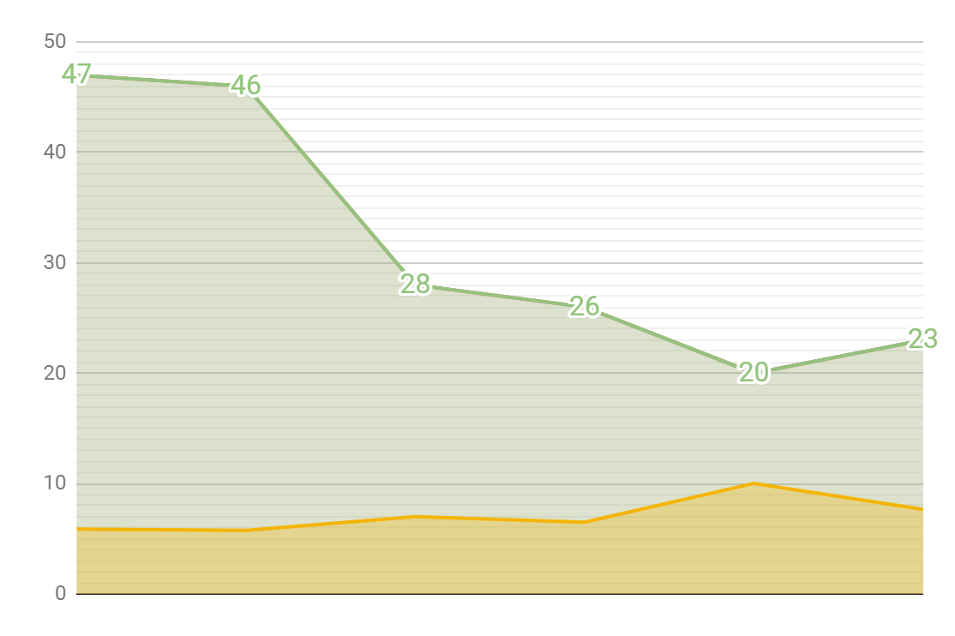

# 8 Graphical User Interface

In this final section of the document we present the GUI for the final system implementation. We will just show the general looks of each page composing the application.

## 8.1 Home Page

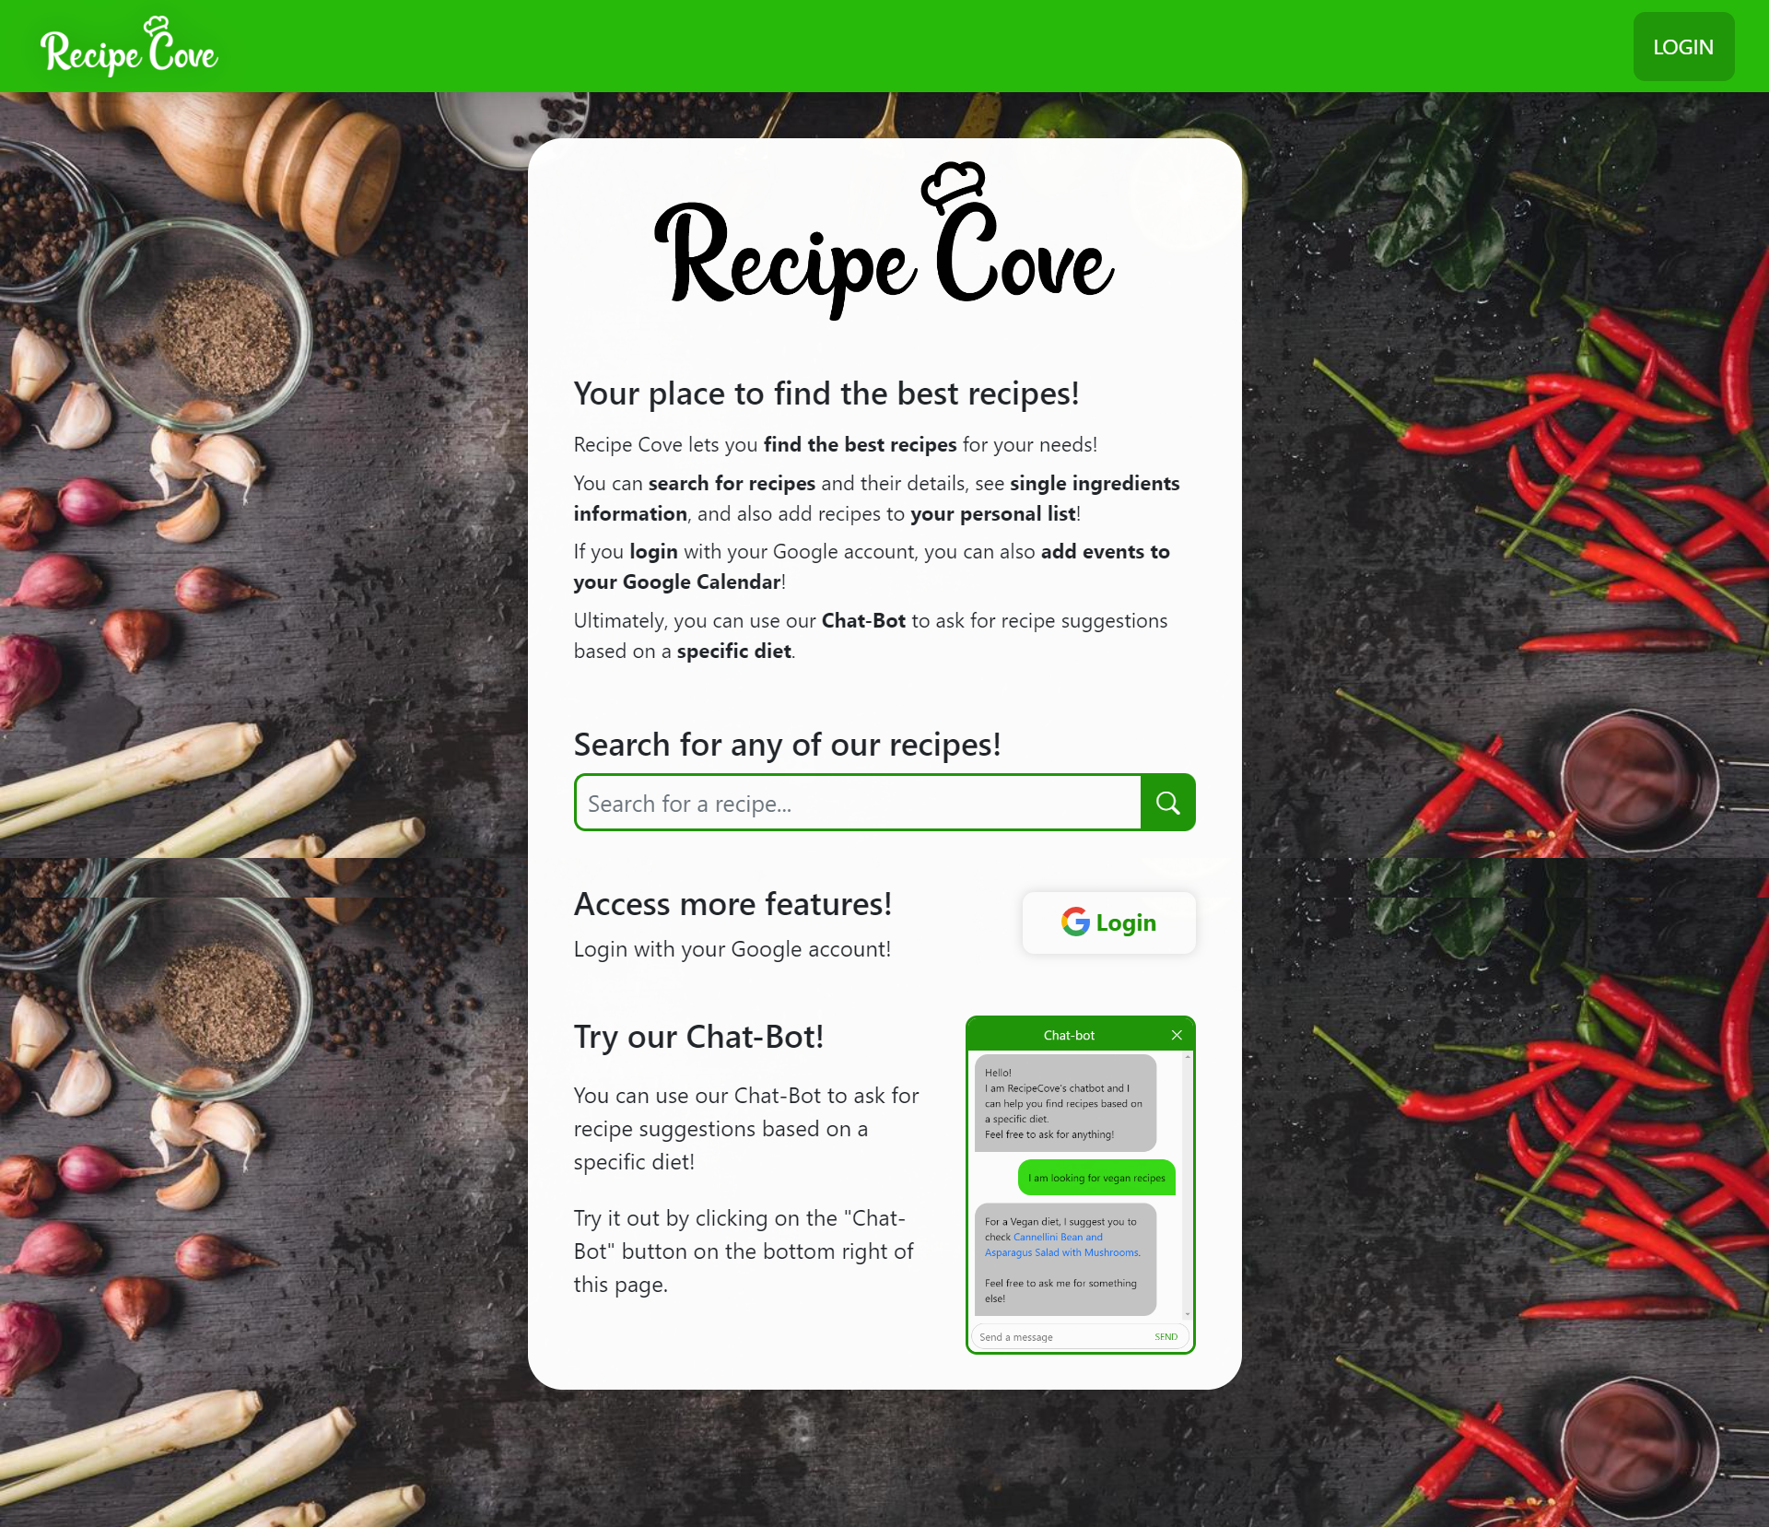

## 8.2 Search Results Page

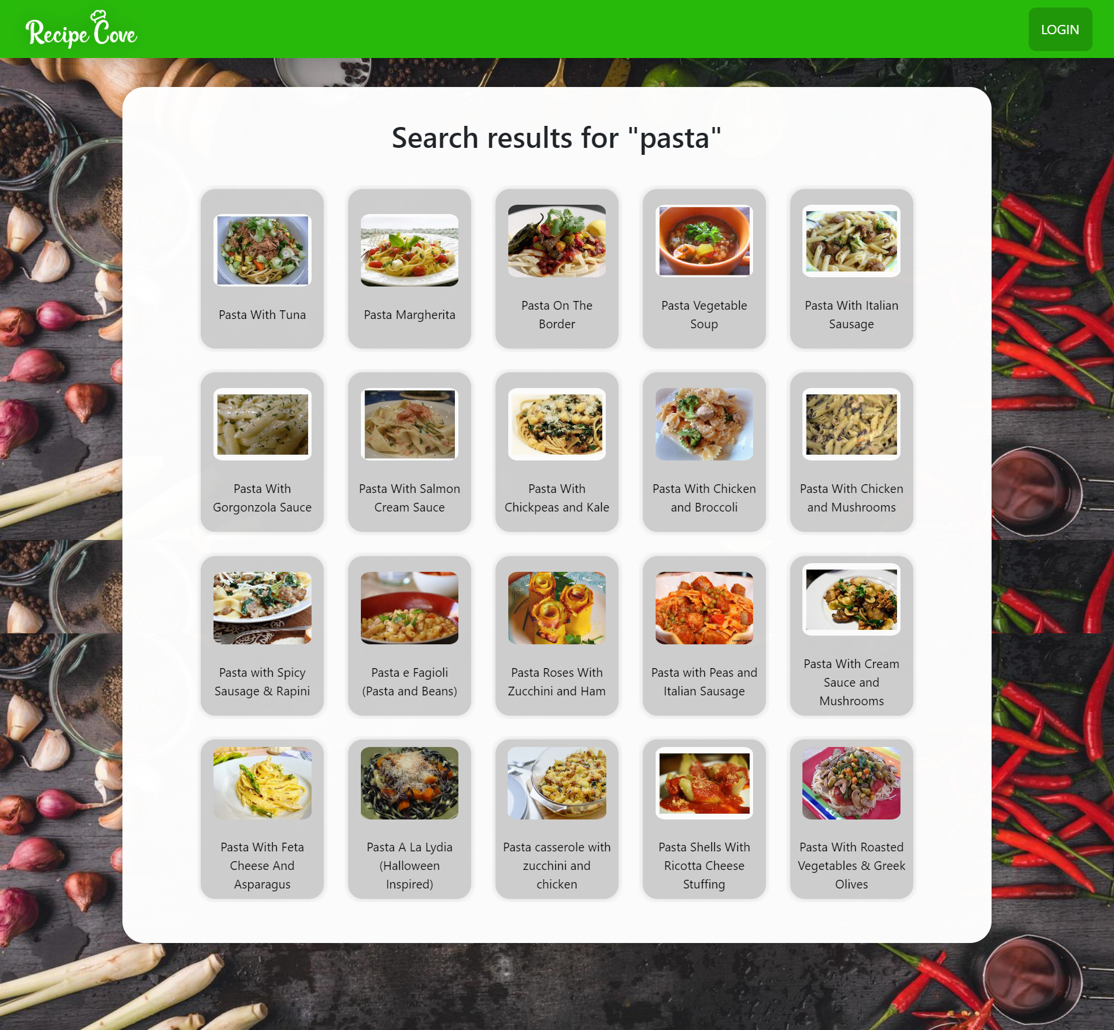

## 8.3 Recipe Page

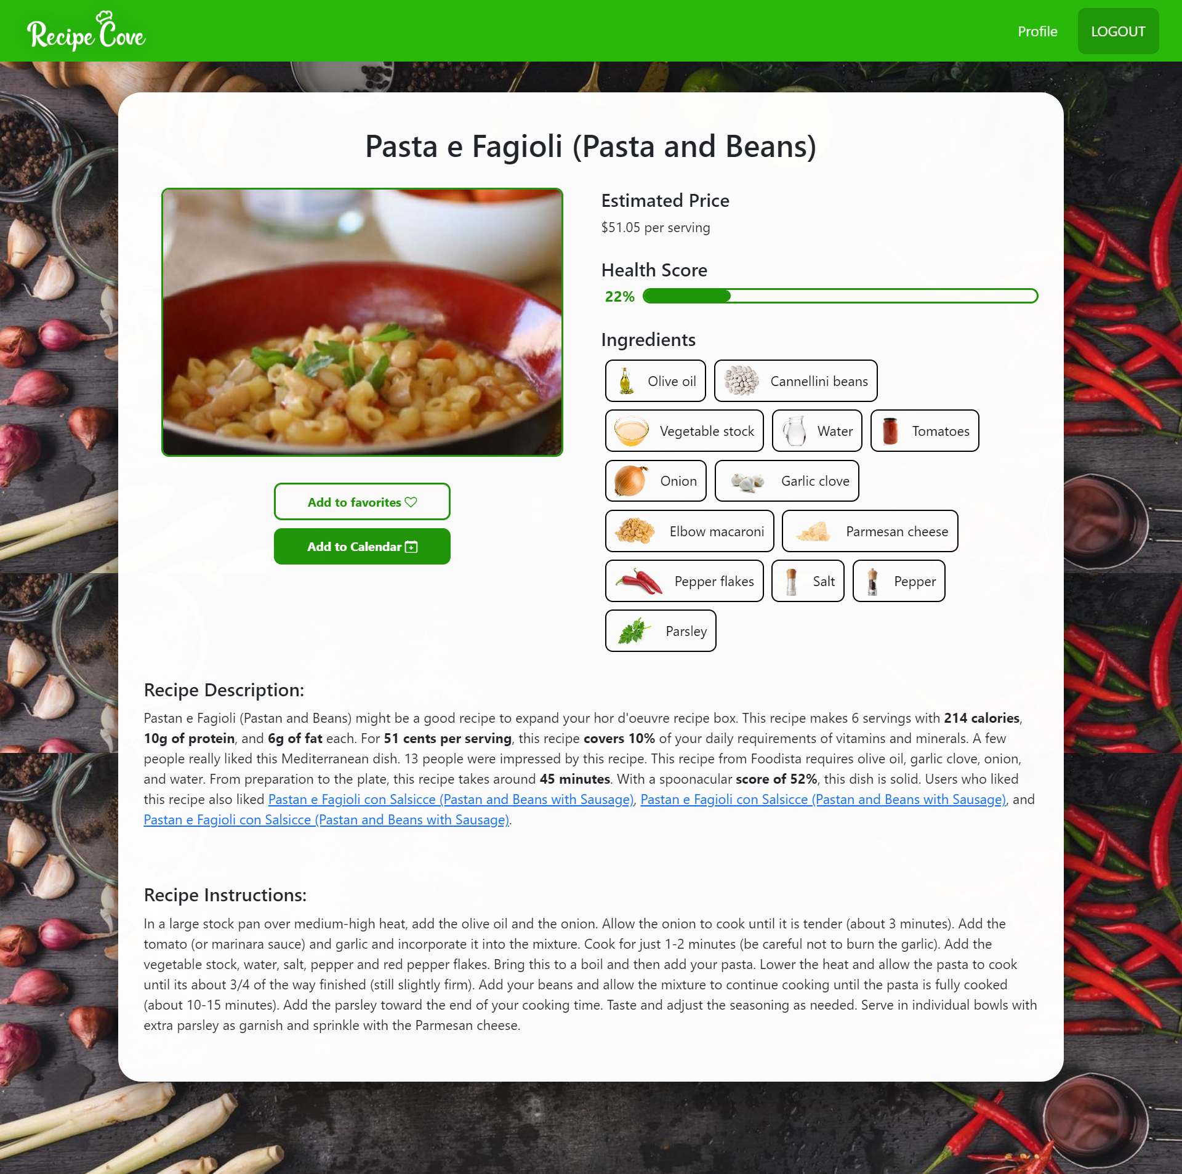

## 8.4 Ingredient Page

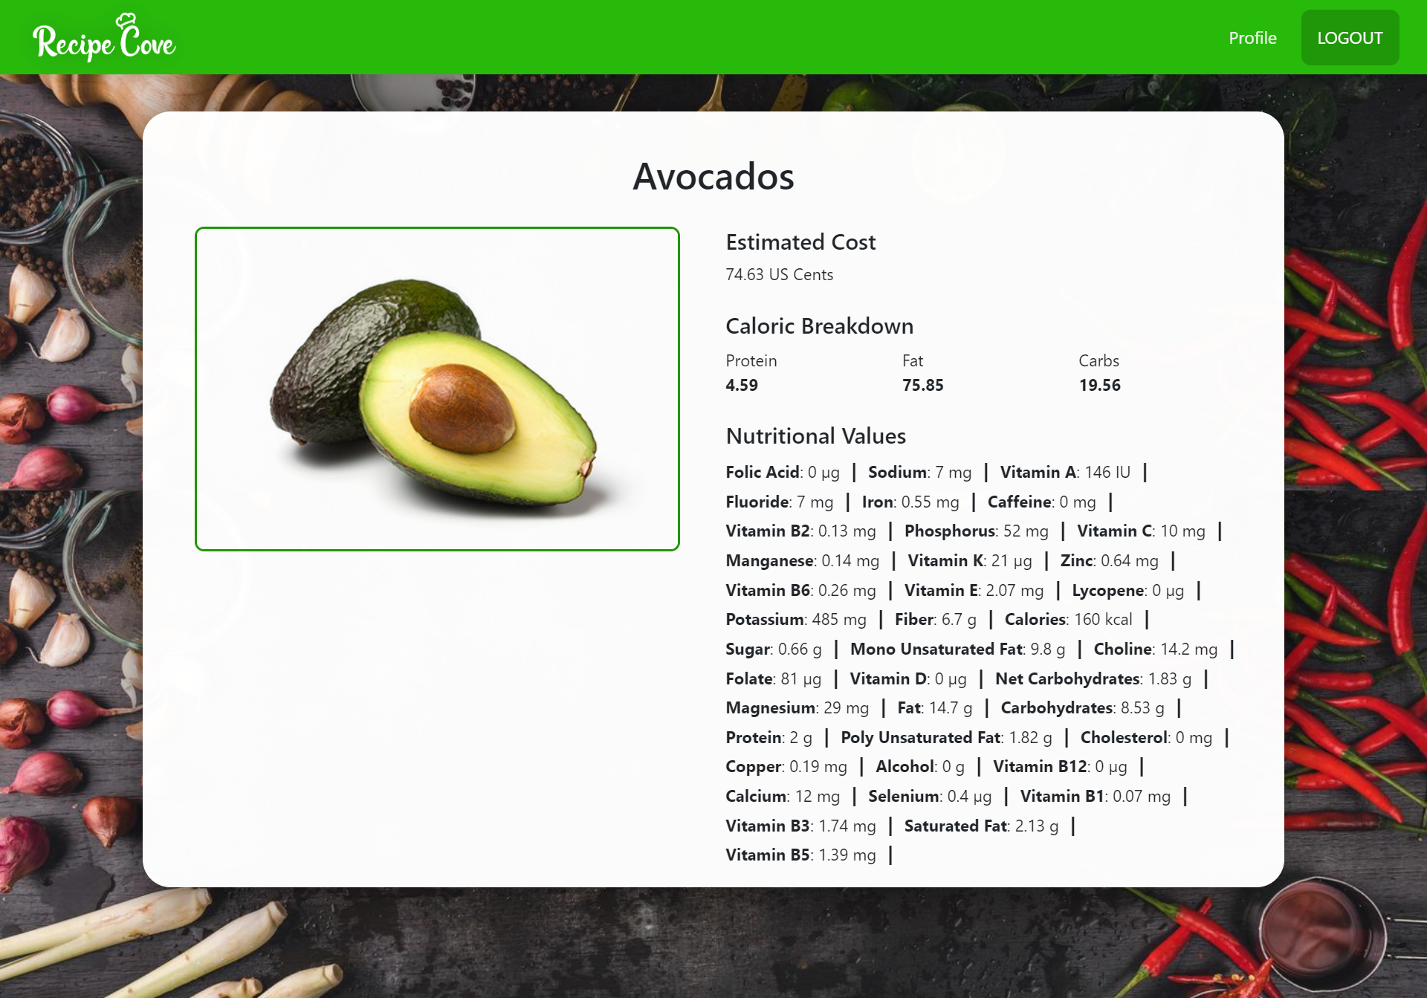

## 8.5 User Profile page

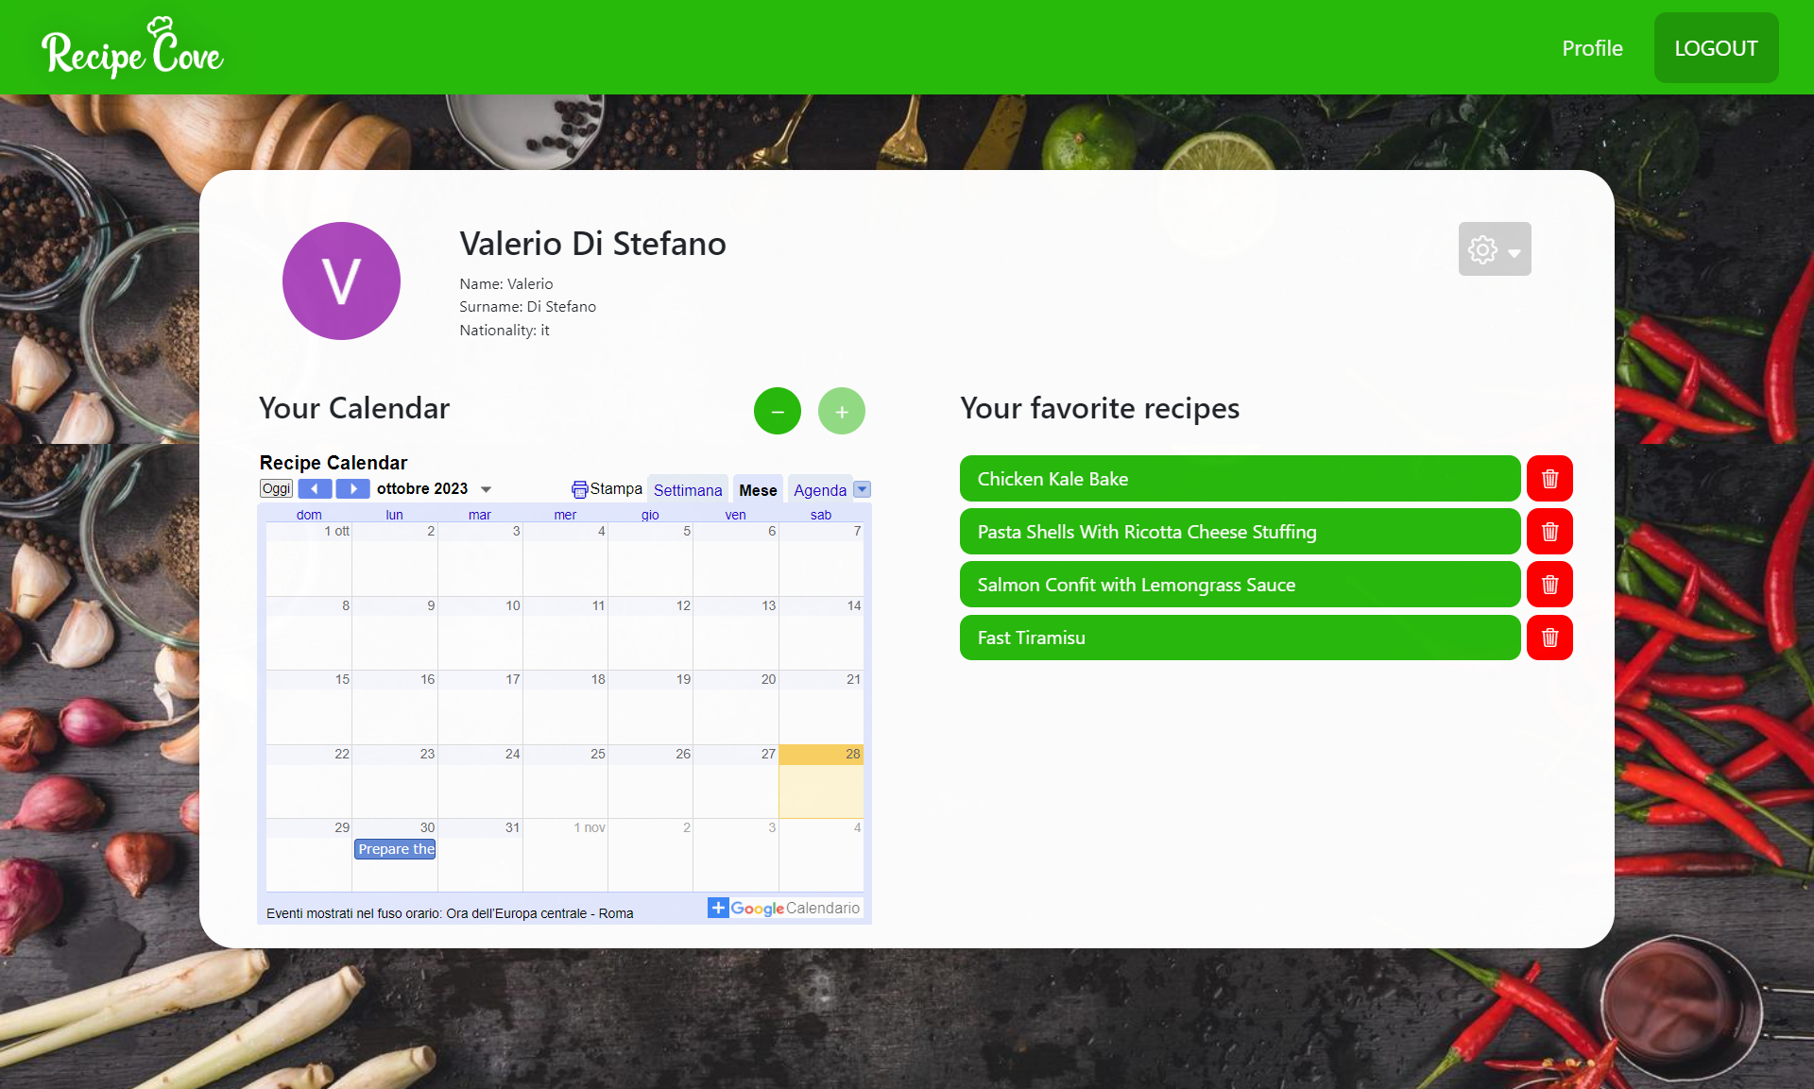

## 8.6 Recipe Calendar Event

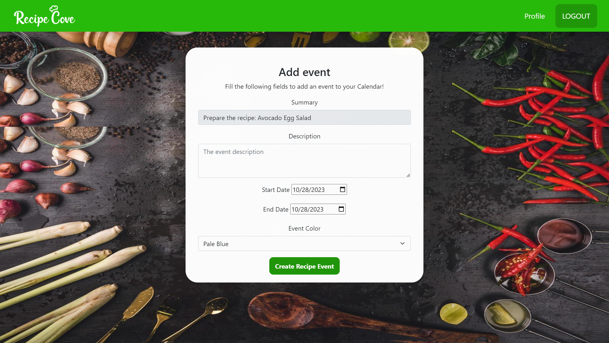

## 8.7 Chat-BOT (Menu)

